Effects of landscape agricultural intensification and management on weed species richness in the edges of dryland cereal fields.

Romero, A., Chamorro, L., Blanco-Moreno, J. M., Armengot, L., Jose María, L. & Sans, F. X.

Key words: Landscape agricultural intensification, weed diversity, crop edges, dryland cereals.

Abstract

An extensive survey of weed vegetation was conducted in the crop edges of 180 organic and conventional dryland cereal fields in nine localities of NE Iberian Peninsula to assess the effect of landscape agricultural intensification and management on weed diversity.

This preliminary results show that averaged weed species richness per edge (alpha-diversity) and floristic homogeneity among edges are higher in organic than conventional fields. Only in conventionally managed fields, elevated landscape intensification is associated to higher weed alpha-diversities and floristic homogeneity among crop edges.

The expression of high-quality weed flora is higher in organic than in conventional crop edges but, conversely, it is only sensitive to landscape intensification in organic fields, being clearly favoured in low-intensified landscapes.

Introduction

Organic farming enhances weed diversity and abundance in dryland cereal fields (Hole et al., 2005) and facilitates the settling of characteristic segetal weeds –i.e. weed species which thrive almost exclusively in cereal fields. Within each management type (organic or conventional), the observed variability in weed diversity patterns among different cereal areas may be due to different farming intensity levels but also to landscape features such as agricultural intensification.

Several authors have studied the effect of landscape agricultural intensification on weed diversity of dryland cereal fields (Roschewitz et al., 2005). Landscape agricultural intensification, easily measured by the percentage of arable land, has been shown to be negatively correlated to other landscape features such as diversity, density of edges among patches or fragmentation of arable habitat. These features may differentially affect some aspects of weed populations’ dynamics such as dispersion or survival through the distribution of safe-sites and connected patches, and consequently, may be related to diversity patterns at alpha, beta and gamma levels.

The aim of this work is to test the hypothesis that landscape complexity may modulate the effect of management system on weed species richness. To achieve it, an extensive weed survey was carried out in the field edges of 180 conventional and organic fields, in nine cereal localities of central Catalonia (NE Iberian Peninsula). As crop edges allow for a higher expression of weed diversity and are less dependent on management intensity than inner fields, they were considered especially appropriate to register landscape effects over farming intensity effects.

Materials and methods

In each locality a circular area of 12.57 km² was delimited. The nine studied localities shared brown lime soils and a Mediterranean climate. Between six and eight organically managed dryland cereal fields and between 12 and 14 conventionally managed ones were surveyed in each locality. Selection of fields was carried out a priori on orthophotographs and later in the field, those which were not sown with wheat or barley, or showed extreme values for aspect or size were discarded. In June of 2005, the weed vegetation of each field was surveyed in a rectangular sample of 20 x 5 m² set in the crop edge, half a meter inside the field from the cultivation limit and with the longest side of the rectangle parallel to the field margin. Each species in the sample was identified and its cover estimated by means of an ordinal scale which ranged from 1 to 5.

For each locality and management type, the averaged value of weed species richness per field (S_{α}) and the accumulated weed species richness across all the surveyed fields (S_{γ}) were obtained. The homogeneity of weed species distribution across the fields was computed as the ratio of the alpha to the gamma value, corrected for the different number of surveyed fields (Jost, 2006). Characteristic segetal species richness for each locality and management type was computed through the pooling of six fields (the minimum number of fields surveyed in a locality and a management type). Then, the pooling was randomly repeated until 1000 resamples were achieved and the average value was calculated.

Landscape agricultural intensification in each locality was estimated by the percentage of arable land in the 12.57 km² area, obtained from official habitat maps (Generalitat de Catalunya, 2005) worked at 1:25.000. This value showed highly significant correlations with landscape physiognomic diversity (r = -0.93, P< 0.001), density of edges among arable land and natural habitats (r = -0.78, P< 0.01) and arable habitat fragmentation (r = +0.77, P< 0.01).

To test the effect of landscape and management type on the aforementioned weed diversity descriptors, weighted lineal models were designed. For each combination of landscape intensification and management, the weight was proportional to the number of fields surveyed and the inverse of the variance of each weed diversity descriptor. Differences between management types were tested with paired t-tests. One locality was considered outlier for organic management and removed from analysis. Statistical analyses were carried out using R (R Development Core Team, 2006).

Results

Crop edges of organic fields sustained higher averaged weed species richness than conventional ones, and a marginal lineal positive relation with the ratio of arable land was only observed in conventional fields. Homogeneity of weed species richness distribution in a locality followed a similar pattern, as it was also higher in organic than conventional fields and was linearly related to landscape intensification in the latter ones (P< 0.05) (Tab. 1, Figure 1).

Tab. 1: Mean ± standard error of the weed diversity estimators studied.
 | Conventional | Organic
Averaged species richness per field | 8.96 ± 1.062 | 15.45 ± 1.211 | **
Homogeneity | 0.19 ± 0.013 | 0.32 ± 0.021 | ***
Segetal species richness | 3.16 ± 0.576 | 7.15 ± 1.345 | *
* Significant for P<0.05, ** significant for P< 0.01, ***significant for P<0.001

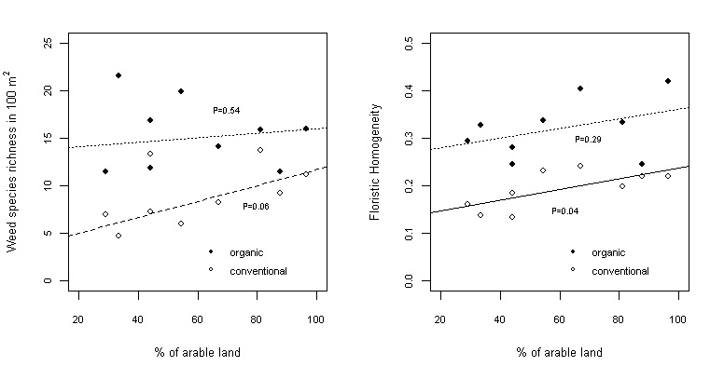
Figure 1: Mean species richness (left) and homogeneity of species richness distribution (right) of weeds with respect to landscape agricultural intensification. P-values of lineal models are next to each line.

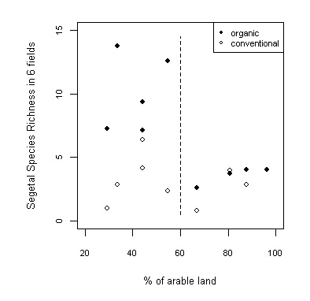
Figure 2: Segetal species richness accumulated across 6 fields with respect to landscape agricultural intensification. The vertical line remarks the change in the pattern for organic fields.

The pool of characteristic segetal weed species accumulated across six crop edges followed an interesting pattern. Differences in accumulated segetal species richness between management types were unappreciable in the four localities with the highest percentages of arable land but became clear in the less intensified landscapes, where organic fields displayed more elevated values (Figure 2).

Discussion and Conclusions

It is well-known that organic farming favours weed species richness. In this preliminary work we have shown that agriculturally intensified landscapes homogenize weed species distribution among dryland cereal crop edges only in conventionally managed fields. In intensified localities, dispersal and survival of ruderal/nitrophilous weed populations could be enhanced by the abundance of ruderal neighbouring habitats such as temporal fallows and highly disturbed roadsides. This hypothesis could also explain the increase in alpha weed species richness associated to landscape agricultural intensification in conventional crop edges. Though only marginally significant, this pattern does not seem to be consistent with other results obtained in central Europe (see Roschewitz et al., 2005). It is worth noting that this pattern was not observed in organic crop edges, probably because weed species richness is sufficiently high so that the contribution of neighbouring habitats cannot be detected.

Conversely, segetal species richness, which could be interpreted as high-quality diversity, seems to be negatively affected by landscape intensification (Figure 2), but only in organic fields. The high intensity of conventional management constitutes an unavoidable barrier to the presence of such specialist species that invalidates any possible landscape effect there, but organic farming seems to need low-intensified landscapes to achieve the highest levels. As an explanation, we propose that the pool of segetal species could have been lessened and substituted by a ruderal/nitrophilous species’ one in intensified landscapes. Experimental studies should be conducted to determine the causes of the patterns highlighted in this work.

Acknowledgments

The authors thank the participating organic and conventional farmers. We also thank Albert Ferrer for his help with landscape data calculations. This research was partially funded by the Spanish Ministry of Education and Science with a fellowship to the first author, by the GDRE "Mediterranean and Mountain Ecosystems in a Changing World", and by the Science and Technology Department of the Spanish Government (project CGL2006-13190-c03-01/BOS).

References

Generalitat de Catalunya. Departament de Medi Ambient i Habitatge (2005): Cartografia dels habitats de Catalunya, http://mediambient.gencat.net/cat/el_medi/habitats/inici.htm, (accessed June-2006).

Hole, D. G., Perkins, A. J., Wilson, J. D., Alexander, I. H., Grice, P. V., Evans, A. D. (2005): Does organic farming benefit biodiversity? Biol. Conserv. 122:113-130.

Jost, L. (2006): Entropy and diversity. Oikos 113: 363-375.

Roschewitz, I., Gabriel, D., Tscharntke, T., Thies, C. (2005): The effects of landscape complexity on arable weed species diversity in organic and conventional farming. J. Appl. Ecol. 42:873-882.

Departament de Biologia Vegetal, Universitat de Barcelona. Av. Diagonal, 645, 08028 Barcelona, Spain. E-mail: albertromeropuente@ub.edu

