Genomic prediction of UAV-phenotyped ground cover in organic spring Wheat and Oat
or
UAV Phenotyping and Genomic Prediction of Ground Cover to Accelerate Organic Spring Cereal Breeding

Khalid Mahmood¹, Lukas Oertelt², Jihad Orabi¹, Janni Hedensvang Jørgensen¹, Hans Ravn Haldrup¹, Ahmed Jahoor^{1,2}, Pernille Sarup¹
¹Nordic Seed A/S Kornmarken 1, 8464 Galten, Denmark
²Nordic Seed Germany, Kirchhorster str. 16 ,31688 Nienstädt, Germany

Abstract
Ground cover is a key trait in organic cereal production, contributing to weed suppression, soil protection, and yield stability. Assessing canopy development manually is labor-intensive, whereas unmanned aerial vehicle (UAV) phenotyping offers a high-throughput and objective alternative. In this study, we evaluated the potential of UAV-derived ground cover measurements combined with genomic prediction to support breeding for organic spring oat (Avena sativaL.) and wheat (Triticum aestivum L.). A diverse panel of 461 oat genotypes and 218 spring wheat genotypes were phenotyped using UAVs in May and June. Ground cover exhibited substantial variation in May (oat: mean = 0.43, SD = 0.31; wheat: mean = 0.36, SD = 0.35) and approached to maturity in June. Narrow-sense heritabilities were intermediate for both species and growth stages (0.30–0.50), indicating moderate genetic control. Genomic prediction models showed higher accuracy for early-season ground cover (May: 0.45) compared with later stages (June: 0.35), consistent with greater phenotypic variation at early growth. Positive correlations were observed between early ground cover and grain yield suggesting that selection for early canopy development can be very useful for organic farming. These results demonstrate that UAV-based phenotyping, integrated with genomic prediction, provides an efficient strategy for selecting competitive, high-yielding cultivars in organic spring cereals, particularly through early-season canopy traits.
Keywords: UAV phenotyping, genomic prediction, ground cover, spring oat, spring wheat, organic breeding, early canopy development

Introduction
Ground cover is the proportion of soil surface occupied by crop canopy and is a fundamental trait in organic cereal production systems, particularly for spring wheat (Triticum aestivum L.) and oat (Avena sativa L.) (Marcinkevičienė et al. 2025; Weiner et al. 2001; Welch et al. 2016). In organic farming, where synthetic herbicides are prohibited, early and dense canopy development is a primary trait for weed suppression (Gallandt 2014; Liebman and Davis 2009). Crops that rapidly establish ground cover effectively compete with weeds for light, water, and nutrients, thereby limiting weed germination and growth (Teasdale 1996; Teasdale et al. 2007). This natural weed competitiveness contributes directly to yield stability and is an essential target trait for organic breeding programs (Pester et al. 1999; Worthington and Reberg-Horton 2013). Beyond weed control, ground cover reduces soil erosion, improves infiltration, and enhances moisture retention, thereby maintaining soil structure and preventing nutrient losses (Blanco and Lal 2008; Daryanto et al. 2018; Zuazo and Pleguezuelo 2009). The continuous vegetative cover also encourages soil microbial activity and nutrient cycling, contributing to long-term soil fertility and system resilience (Scavo et al. 2022; Govaerts et al. 2008; Lori et al. 2017). Moreover, dense canopy development improves light interception and resource-use efficiency, supporting biomass accumulation and yield stability under low-input conditions (Murphy et al. 2008; Reynolds et al. 2009; Harbo et al. 2022). Hence, breeding for organic cereals using improved ground cover aligns with broader goals of ecological resilience and long-term soil health.
In breeding schemes, rapid and uniform canopy development in spring wheat and oat is therefore a desirable trait, combining agronomic performance with ecological benefits. However, conventional methods for assessing ground cover rely on manual visual scoring by breeders throughout the growing season (Sadeghpour et al. 2014; Booth et al. 2006). Such evaluations are time-consuming, sometimes biased, and labor-intensive, restricting both accuracy and scalability, particularly across large breeding populations or multi-environment trials (Booth et al. 2008; Chawade et al. 2019). Recent advances in high-throughput phenotyping (HTP) have opened new opportunities to overcome these constraints (Chawade et al. 2019). Unmanned aerial vehicles (UAVs) equipped with multispectral or high-resolution RGB sensors have become powerful tools for monitoring canopy traits objectively and efficiently (Herzig et al. 2021; Hu et al. 2021). UAV-derived measurements of ground cover correlate strongly with manual breeder scores while providing finer spatial and temporal resolution, enabling consistent, large-scale phenotyping across environments and management systems (Herzig et al. 2021; Gano et al. 2024; Hu et al. 2021; Gracia-Romero et al. 2019).
Integrating such UAV-derived phenotypes with genomic prediction frameworks offers a promising strategy to accelerate genetic improvement for complex traits such as ground cover (Ge et al. 2025). Genomic prediction powers genome-wide marker information to estimate breeding values even in early generations, where field trials are limited or not yet sown (Desta and Ortiz 2014). This integration enables selection of the cereals based on predicted performance, thereby increasing selection efficiency, reducing phenotyping costs, and potentially shortening the breeding cycle to develop cultivars suitable for organic agriculture.
The present study aimed to evaluate the potential of genomic prediction for UAV-derived ground cover trait in the organic field trials of spring wheat and oat. Using data from organic field trials, we estimated the heritability of UAV-based ground cover measurements and developed genomic prediction models to assess their predictive accuracy. Model performance was evaluated using a leave-one-line-out (LOLO) cross-validation approach. To our knowledge, this is the first study integrating UAV phenotyping with genomic prediction to estimate ground cover in the context of organic spring wheat and oat breeding. Collectively, these analyses provide insights into the feasibility of combining UAV-based phenotyping with genomic prediction to improve ground cover—a trait closely associated with weed suppression, soil conservation, and the overall sustainability of organic cereal production systems.

Material and methods
Field trials
The spring wheat plant material consisted of in total 218 unique genotypes of the spring wheat (Triticum aestivum) 173 of the genotypes where from the breeding population at Nordic Seed A/S representing 6 breeding cycles. The genotypes were tested in 1599 organic field grain yield trial plots. All plots were 8.25 m² (5.5 × 1.5 m). Ground cover was scored by UAV once in may each location and year. The descriptive statistics for ground cover for organic trials is presented in table 1.
Field trials were conducted in 2019 – 2022 in a randomized incomplete block design with 150 genotypes per trial, 25 subblocks per trial, and 2 reps per genotype. Trials were conducted on 2 locations Hellevad, DK (GPS coordinates: 55067688 E, 9238965 N), and Dybvad, DK (GPS coordinates: 571317 E, 6196886 N).

The oat plant material consisted of in total 461 unique genotypes of the spring oat (Avena sativa) breeding population at Nordic Seed A/S representing 3 breeding cycles. The genotypes were tested in 1340 organic field grain yield trial plots. All plots were 8.25 m² (5.5 × 1.5 m). Ground cover was scored by UAV twice in each location and year, once in spring and once in early summer. The descriptive statistics for ground cover for organic trials is presented in table 1.
Field trials were conducted in 2022 – 2024 in a randomized incomplete block design with 150 genotypes per trial, 25 subblocks per trial, and 2 reps per genotype. Trials were conducted on 2 locations Hellevad, DK (GPS coordinates: 55067688 E, 9238965 N), and Dybvad, DK (GPS coordinates: 571317 E, 6196886 N).
The DNA extraction was performed using an updated SDS method as described by Mahmood et al., (Mahmood et al, 2024). The spring wheat plant material was genotyped using an Illumina iSelect wheat chip. A total of 20,919 single-nucleotide polymorphism (SNP) markers were utilized. Quality control was done by removing SNPs with minor allele frequency (MAF) lower than 1% and call rate lower than 0.90. Genotypes were coded -1,0,1, counting the number of alleles of the reference allele for each locus. Missing genotypes were ~0.3 % and were assigned 0.
The oat plant material was genotyped using an Illumina iSelect oat chip. A total of 1006 single-nucleotide polymorphism (SNP) markers were utilized. Quality control was done by removing SNPs with minor allele frequency (MAF) lower than 1% and call rate lower than 0.90. Genotypes were coded -1,0,1, counting the number of alleles of the reference allele for each locus. Missing genotypes were ~0.3 % and were assigned 0.
Statistical modeling
Genomic models
A standard genomic model was used to assess heritability in all traits and genomic prediction of ground cover in organic trials.
$$y= Xb+Z_{g}g+ Z_{l}l+ Z_{gxe}gxe + Z_{t}t+ Z_{sb}sb+e$$
Where X and Z_{x} is design matrices for fixed and random effects respectively; b is a vector of fixed trial effects nested within year and location, g is a vector of random additive genetic effects with $g \sim N\left(0,Gσ_{g}^{2}\right)$, where $σ_{g}^{2}$ is the genomic additive genetic variance, and G is the genomic relationship matrix (G-matrix). The G-matrix was constructed based on the first method proposed by VanRaden (2008):
$G=\frac{ZZ^{'}}{2\sum{p_{i}(1-p_{i})}}$ (3)
where $p_{i}$ is the minor allele frequency of the $i^{th}SNP;$ $Z$ was calculated as $Z=M-P$; $M$ is a matrix of SNP markers coded -1,0,1; and $P$ is a matrix with the minor allele frequencies of SNP $i$ calculated as $1(2\left(p_{i}-0.5\right))$ for column $i$; l is a vector of line effects with $l \sim N\left(0,Iσ_{l}^{2}\right)$, where $I$ is an identity matrix and $σ_{l}^{2}$ is the variance due to uncorrelated line effects; gxe is a vector of genotype times year_location interactions with $gxe \sim N\left(0,Iσ_{gxe}^{2}\right)$, where $σ_{gxe}^{2}$ is the variance due to due to uncorrelated genotype by environment effects; t is a vector of block effects with t$\sim N\left(0,Iσ_{t}^{2}\right)$ where $σ_{t}^{2}$ is the spatial variance due to due to block within field, and sb is a vector of subblock effects with t$\sim N\left(0,Iσ_{sb}^{2}\right)$ where $σ_{sb}^{2}$ is the spatial variance due to due to subblock within field.
Heritability calculations
Line mean heritabilities were calculated as
$${\hat{h}}^{2}= d(G){\hat{σ}}_{g}^{2}/(d\left(G\right){\hat{σ}}_{g}^{2}+ {\hat{σ}}_{l}^{2}+ {{\hat{σ}}_{gxe}^{2}}/{n_{gxe}}+ {{\hat{σ}}_{t}^{2}}/{n_{t}}+ {{\hat{σ}}_{sb}^{2}}/{n_{sb}}+ {{\hat{σ}}_{e}^{2}}/{n_{e}})$$
Where d(G) is the average of the diagonal elements in the G matrix, $n_{gxe}$is the average number of year_location environments per line; $n_{t}$is the average number of plots per block; $n_{sb}$is the average number of plots per subblock; and $n_{e}$is the average number of plots per line.
The relative variance component for each of the other effects in the model was calculated as follows.
$$\hat{l}= {\hat{σ}}_{l}^{2}/(d\left(G\right){\hat{σ}}_{g}^{2}+ {\hat{σ}}_{l}^{2}+ {{\hat{σ}}_{gxe}^{2}}/{n_{gxe}}+ {{\hat{σ}}_{t}^{2}}/{n_{t}}+ {{\hat{σ}}_{sb}^{2}}/{n_{sb}}+ {{\hat{σ}}_{e}^{2}}/{n_{e}})$$
$$\hat{gxe}=({{\hat{σ}}_{gxe}^{2}}/{n_{gxe}})/(d\left(G\right){\hat{σ}}_{g}^{2}+ {\hat{σ}}_{l}^{2}+ {{\hat{σ}}_{gxe}^{2}}/{n_{gxe}}+ {{\hat{σ}}_{t}^{2}}/{n_{t}}+ {{\hat{σ}}_{sb}^{2}}/{n_{sb}}+ {{\hat{σ}}_{e}^{2}}/{n_{e}})$$

$$\hat{t}=({{\hat{σ}}_{t}^{2}}/{n_{t}})/(d\left(G\right){\hat{σ}}_{g}^{2}+ {\hat{σ}}_{l}^{2}+ {{\hat{σ}}_{gxe}^{2}}/{n_{gxe}}+ {{\hat{σ}}_{t}^{2}}/{n_{t}}+ {{\hat{σ}}_{sb}^{2}}/{n_{sb}}+ {{\hat{σ}}_{e}^{2}}/{n_{e}})$$

$$\hat{sb}=({{\hat{σ}}_{sb}^{2}}/{n_{sb}}) /(d\left(G\right){\hat{σ}}_{g}^{2}+ {\hat{σ}}_{l}^{2}+ {{\hat{σ}}_{gxe}^{2}}/{n_{gxe}}+ {{\hat{σ}}_{t}^{2}}/{n_{t}}+ {{\hat{σ}}_{sb}^{2}}/{n_{sb}}+ {{\hat{σ}}_{e}^{2}}/{n_{e}})$$
$$\hat{e}=({{\hat{σ}}_{e}^{2}}/{n_{e}}) /(d\left(G\right){\hat{σ}}_{g}^{2}+ {\hat{σ}}_{l}^{2}+ {{\hat{σ}}_{gxe}^{2}}/{n_{gxe}}+ {{\hat{σ}}_{t}^{2}}/{n_{t}}+ {{\hat{σ}}_{sb}^{2}}/{n_{sb}}+ {{\hat{σ}}_{e}^{2}}/{n_{e}})$$

CV strategies and PA calculations
The predictive performance of the genomic models was evaluated by a leave one line out (LOLO) cross validation.
Predictive ability was calculated as the correlation between the cross validated additive genomic value for ground cover and the line mean ground cover corrected for fixed effects estimated by the genomic model.
Genetic correlations
It is difficult to get precise estimates of genetic correlations between traits with intermediate heritabilities and sample sizes, instead we correlated the breeding values obtained from the genomic models for ground cover in May and June in oat. In addition we correlated the breeding values for ground cover with the breeding values for yield obtained from a genomic model for organic grain yield for oat (REF to the other paper) and wheat (genomic analysis not shown).
Software
R 4.03 was used for preparing datasets and performing the PCA analysis. DMU was used for the genomic analysis (Madsen et al. 2014).
Results
Principal component analysis (PCA) revealed no distinct population structure among the 461 oat genotypes (Figure 1). Even the distribution of genotypes across the first two PCA indicates that the breeding material is genetically diverse yet lacks strong sub-population differentiation. These results show that the breeding population in both crops is suitable for standard genomic prediction models without the need for additional correction for population structure.
UAV-derived ground cover phenotypic data for organic oat and wheat is presented in Table 1. For oat, ground cover measured in May showed a mean value of 0.43 with a relatively high standard deviation (SD = 0.31), ranging from 0.02 to 1.00, indicating considerable variation among genotypes and plots during early canopy development. By June, the mean ground cover had increased significantly to 0.94 (SD = 0.07), with values ranging from 0.54 to 1.00, suggesting that most oat plots had achieved near-complete canopy closure by this stage. In spring wheat, drone-based ground cover measurements taken in May exhibited a mean of 0.36 (SD = 0.35) and a range from 0.00 to 1.00, similarly reflecting substantial phenotypic variability during early growth. Overall, the results indicate that UAV phenotyping successfully captured the expected temporal increase in ground cover from May to June and revealed high variation among genotypes in both crops during early growth stages which is an essential prerequisite for effective genomic prediction and selection for canopy development in organic cereal breeding.
Estimates of variance components and narrow-sense heritability for the UAV-derived ground cover traits are summarized in Table 2. Both ground cover measurements in oat showed heritability estimates that were significantly greater than zero, but not statistically different from each other (Table 2). The heritability estimate for ground cover in May was 0.33 ± 0.07, and for June it was 0.30 ± 0.07, indicating a moderate level of genetic control at both stages of crop development. For oat ground cover measured in May, the genotype-by-environment interaction accounted for the largest proportion of the total variance (0.42 ± 0.07), followed by location effects (0.12 ± 0.07) and residual variance (0.14 ± 0.02). This suggests that early canopy development in oat was influenced by both genetic and environmental factors, with a noticeable genotype-by-environment component. In contrast, for ground cover assessed in June, the environmental variance was higher (0.25 ± 0.01) and the genotype-by-environment interaction was negligible (0.0004 ± 0.04), indicating that ground cover became more stable across environments once the canopy had fully developed.
For spring wheat, drone-based ground cover measured in May showed a higher heritability of 0.50 ± 0.10, suggesting stronger additive genetic control compared with oat. Genotype-by-environment interaction also contributed remarkably to the total variance (0.33 ± 0.05), while environmental variance remained relatively low (0.09 ± 0.01). These results indicate that UAV-derived measurements effectively captured genetic variation for ground cover in both organic oat and wheat sown in spring. The moderate to high heritability estimates, particularly for wheat, demonstrate that ground cover can be a reliable target trait for genomic prediction and selection. Moreover, the reduced genotype-by-environment interaction at later stages highlights the potential stability of UAV-phenotyped ground cover as a breeding trait under organic field conditions.
The prediction ability for ground cover measured in May was 0.45 ± 0.04 (Figure 2), while that for June was 0.35 ± 0.04 (Figure 3). These results indicate that the genomic model was able to capture a substantial proportion of the genetic variance underlying ground cover, particularly at the early stage of canopy development. The higher prediction ability observed in May suggests that early-season ground cover, when phenotypic variation among genotypes is greatest, is more strongly associated with the underlying genetic signal detectable by molecular markers. By contrast, the slightly lower predictive accuracy for June is consistent with the reduced phenotypic variance observed at this later stage, when most plots had reached near-complete canopy closure and environmental factors dominated the remaining variation. In wheat prediction ability was 0.52 (0.07) (Figure 4). This higher predictions observed in spring wheat suggest that genomic model capture substantial larger proportion of the genetic variance underlying ground cover of spring wheat (Figure 4).
The correlations between UAV-derived ground cover traits and organic grain yield are summarized in Table 3. For oat, ground cover measured in May and June were positively correlated (r = 0.64, p = 2.2 × 10⁻¹⁶), indicating that genotypes with greater canopy cover early in the season tended to maintain higher ground cover later in development. Both ground cover traits were also significantly correlated with grain yield. The correlation between May ground cover and yield was r = 0.36 (p = 5.0 × 10⁻⁸), while the correlation between June ground cover and yield was r = 0.40 (p = 6.9 × 10⁻¹¹). These results suggest that oat lines exhibiting more rapid canopy closure early in the growing season generally produced higher organic grain yields, highlighting the agronomic relevance of ground cover as a selection trait for organic grown oat.
For spring wheat, drone-based ground cover measured in May was also positively associated with grain yield (r = 0.24, p = 0.002; Table 3). Although this relationship was weaker than that observed in oat, the correlation remained statistically significant, suggesting that early canopy establishment contributes to improved yield potential under organic conditions in both species.
These correlation analyses demonstrate that UAV-phenotyped ground cover, particularly during early growth stages, is not only a reliable indicator of canopy development but also a useful predictor of yield in organic grown spring oat and wheat. These findings support the potential use of UAV-based ground cover measurements as indirect selection criteria for yield improvement in organic cereal breeding programs.
Discussion
Phenotypic variation and heritability of UAV-derived ground cover
This study demonstrates that UAV-derived ground cover captures substantial phenotypic variation in oat and spring wheat during early growth stages, consistent with prior research emphasizing the utility of UAV platforms for high-throughput phenotyping in cereals (Ninomiya 2022; Roth et al. 2023). The mean ground cover in May showed ample variation in both species, whereas oat ground cover near canopy closure in June was saturated with reduced variability (Table 1). Intermediate narrow-sense heritabilities (0.30–0.50) across species and timepoints reflect underlying additive genetic control, in agreement with other findings who reported moderate to high heritabilities for canopy-related UAV traits in cereals (Cooper et al. 2024; Makanza et al. 2018). The larger phenotypic variation and heritability in early stages suggest that selection efforts should focus on May measurements, aligning with the recognized importance of early canopy vigor as a predictor of competitive ability and yield in organic and low-input systems (Hendriks et al. 2022; Worthington and Reberg-Horton 2013; Murphy et al. 2005; Hossard et al. 2016; Cao et al. 2021).​
Genetic and environmental variance components
Analysis of variance components highlights that early ground cover variation is strongly influenced by genotype-by-environment (G×E) interactions, while later-stage variation (June) is shaped predominantly by non-additive genetic and environmental compensation effects, reflecting developmental plasticity (Gao et al. 2023; Yang et al. 2020). This progression, from environmentally sensitive early growth to more stable late-stage expression, mirrors patterns reported in related cereal phenotyping studies (Perich et al. 2020; Herzig et al. 2021). The higher heritability and G×E variance for spring wheat’s May ground cover, relative to oat, suggest that genetic diversity and population structure enhance genetic signal extraction under UAV phenotyping. This corresponds with findings by others, who suggested that deeper breeding history increases genetic variance exploitable for genomic selection (Alemu et al. 2024; Mascher et al. 2019).​
Genomic prediction and breeding implications
The improved genomic prediction accuracy for May ground cover in both species compared to June confirms that early vigor traits with higher variability yield stronger genetic signals suitable for prediction modeling. This mirrors results by Robert et al. (2022) and Hu et al. (2020), who integrated UAV phenotyping and genomic selection to accelerate breeding cycles in wheat (Robert et al. 2022; Hu et al. 2020). The ability to detect genetic differences and predict performance using UAV-derived canopy metrics supports deploying this approach to streamline selection processes, particularly under organic conditions where field trials are more heterogeneous and costly.​
Correlation with organic grain yield and trait relationships
This investigation demonstrated significant positive genetic correlations between early ground cover and organic grain yield in both oat and wheat. The strong correlation between early and late canopy ground cover and their respective positive correlations with yield reflect the physiological link between early vigor and resource acquisition efficiency, consistent with reports by Sun et al. (2018) and Seavers and Wright et al. (1999) (Sun et al. 2018; Seavers and Wright 1999). Although spring wheat exhibited a weaker yet significant correlation (r=0.24) between May ground cover and yield, this emphasizes subtle species-specific variance in resource allocation and competitive growth strategies, as discussed by Sinha et al. (2023)(Sinha et al. 2023). These findings reinforce that early ground cover constitutes a robust indirect selection trait for yield improvement in organic systems.​
Broader impact and future directions for organic breeding
The integration of UAV phenotyping with genomic prediction evidenced here strengthens the utility of remote sensing technologies in contemporary breeding programs focused on organic cereals. The combination of high-throughput phenotyping and genomic tools aligns with recent recommendations to improve accuracy and efficiency in selecting complex traits under variable environments(Sinha et al. 2023; Yang et al. 2020). Incorporation of multispectral indices such as NDVI and GNDVI can further enhance physiological trait characterization and stress adaptability assessments (Herzig et al. 2021; Cao et al. 2021). Additionally, expanding this framework across multiple environments and developmental stages would facilitate robust multi-trait genomic prediction models, further refining selection for yield resilience and resource-use efficiency.​ The findings in this study provide strong support for prioritizing early ground cover as a key trait in organic breeding using UAV-derived phenotypes and genomic selection to accelerate genetic gain. This integrated approach fosters development of cultivars with enhanced early vigor, competitive ability, and yield potential tailored to organic agroecosystems, thus contributing to sustainable crop production.
Conclusion
This study demonstrates the potential of integrating UAV-based phenotyping with genomic prediction to enhance selection for ground cover in organic spring oat and wheat breeding. UAV-derived measurements of canopy development effectively captured meaningful phenotypic variation, particularly at early growth stages, when differences among genotypes were most pronounced. The moderate to high heritability estimates indicate that ground cover is under genetic control and can be improved through selection.
Genomic prediction models achieved substantial accuracy, especially for early-season ground cover, confirming that genetics can reliably predict complex canopy traits even in diverse organic populations. The positive genetic and phenotypic correlations between early ground cover, late ground cover, and grain yield further suggest that selection for rapid canopy establishment will indirectly enhance yield potential and weed competitiveness, two key objectives in organic cereal production. By enabling early and objective assessment of canopy development, this approach can accelerate genetic gain for both agronomic performance and ecological resilience in organically managed systems. Future work should focus on multi-environment and multi-year validation, as well as integration with other UAV-derived traits such as canopy temperature and spectral indices, to further refine genomic selection models and support holistic improvement of organic cereal crops.
Funding: This research was conducted as part of the Oatganic project (34009-21-1898) and the Økosort project (project number 34009-18-1341). The projects were partially funded by the Green Development and Demonstration Programme (GUDP) under the Danish Ministry of Food, Agriculture and Fisheries, and coordinated by the International Centre for Research in Organic Food Systems (ICROFS).
Conflicts of Interest: Khalid Mahmood, Pernille Sarup, Janni Hedensvang Jørgensen, Ahmed Jahoor, and Jihad Orabi are employed by Nordic Seed, Denmark, and authors Lukas Oertelt and Ahmed Jahoor are employed by Nordic Seed Germany. The authors declare that the research was conducted in the absence of any financial relationships that could be construed as a potential conflict of interest.
Author Contributions
The original draft of the manuscript was prepared by Pernille Sarup and Khalid Mahmood, with all authors contributing to review and editing of the final version. Project administration was managed by Ahmed Jahoor, Hans Ravn Haldrup, and Jihad Orabi. Field scoring was carried out by Lukas Oertelt for oat and Janni Hedensvang Jørgensen for wheat. Pernille Sarup developed the methodology, performed the data analyses, validation, and visualization, and was responsible for software management and formal analysis. Funding for the research was acquired by Ahmed Jahoor, Hans Ravn Haldrup, Jihad Orabi, and Pernille Sarup. All authors read and approved the final manuscript.
References
Alemu A, Åstrand J, Montesinos-Lopez OA, y Sanchez JI, Fernandez-Gonzalez J, Tadesse W, Vetukuri RR, Carlsson AS, Ceplitis A, Crossa J (2024) Genomic selection in plant breeding: Key factors shaping two decades of progress. Molecular Plant 17 (4):552-578
Blanco H, Lal R (2008) Principles of soil conservation and management, vol 167169. Springer New York,
Booth D, Cox SE, Meikle T, Fitzgerald C (2006) The accuracy of ground-cover measurements. Rangeland ecology & management 59 (2):179-188
Booth DT, Cox SE, Meikle T, Zuuring HR (2008) Ground-cover measurements: assessing correlation among aerial and ground-based methods. Environmental management 42 (6):1091-1100
Cao X, Liu Y, Yu R, Han D, Su B (2021) A comparison of UAV RGB and multispectral imaging in phenotyping for stay green of wheat population. Remote Sensing 13 (24):5173
Chawade A, Van Ham J, Blomquist H, Bagge O, Alexandersson E, Ortiz R (2019) High-throughput field-phenotyping tools for plant breeding and precision agriculture. Agronomy 9 (5):258
Cooper J, Sweet DD, Tirado SB, Springer NM, Hirsch CN, Hirsch CD (2024) Dissecting the temporal phenomics and genomics of maize canopy cover using UAV mediated image capture. biorxiv:2024.2006. 2025.600603
Daryanto S, Fu B, Wang L, Jacinthe P-A, Zhao W (2018) Quantitative synthesis on the ecosystem services of cover crops. Earth-Science Reviews 185:357-373
Desta ZA, Ortiz R (2014) Genomic selection: genome-wide prediction in plant improvement. Trends in plant science 19 (9):592-601
Gallandt E (2014) Weed management in organic farming. In: Recent advances in weed management. Springer, pp 63-85
Gano B, Bhadra S, Vilbig JM, Ahmed N, Sagan V, Shakoor N (2024) Drone‐based imaging sensors, techniques, and applications in plant phenotyping for crop breeding: A comprehensive review. The Plant Phenome Journal 7 (1):e20100
Gao L, Kantar MB, Moxley D, Ortiz-Barrientos D, Rieseberg LH (2023) Crop adaptation to climate change: An evolutionary perspective. Molecular Plant 16 (10):1518-1546
Ge H, Zhang Q, Shen M, Qin Y, Wang L, Yuan C (2025) Enhancing yield prediction in maize breeding using UAV-derived RGB imagery: a novel classification-integrated regression approach. Frontiers in Plant Science 16:1511871
Govaerts B, Mezzalama M, Sayre KD, Crossa J, Lichter K, Troch V, Vanherck K, De Corte P, Deckers J (2008) Long-term consequences of tillage, residue management, and crop rotation on selected soil micro-flora groups in the subtropical highlands. Applied Soil Ecology 38 (3):197-210
Gracia-Romero A, Kefauver SC, Fernandez-Gallego JA, Vergara-Díaz O, Nieto-Taladriz MT, Araus JL (2019) UAV and ground image-based phenotyping: A proof of concept with durum wheat. Remote sensing 11 (10):1244
Harbo LS, De Notaris C, Zhao J, Olesen JE (2022) Productivity, light interception and radiation use efficiency of organic and conventional arable cropping systems. European Journal of Agronomy 132:126407
Hendriks P-W, Gurusinghe S, Ryan PR, Rebetzke GJ, Weston LA (2022) Competitiveness of early vigour wheat (Triticum aestivum L.) genotypes is established at early growth stages. Agronomy 12 (2):377
Herzig P, Borrmann P, Knauer U, Klück H-C, Kilias D, Seiffert U, Pillen K, Maurer A (2021) Evaluation of RGB and multispectral unmanned aerial vehicle (UAV) imagery for high-throughput phenotyping and yield prediction in barley breeding. Remote Sensing 13 (14):2670
Hossard L, Archer DW, Bertrand M, Colnenne‐David C, Debaeke P, Ernfors M, Jeuffroy MH, Munier‐Jolain N, Nilsson C, Sanford GR (2016) A Meta‐Analysis of Maize and Wheat Yields in Low‐Input vs. Conventional and Organic Systems. Agronomy Journal 108 (3):1155-1167
Hu P, Chapman SC, Zheng B (2021) Coupling of machine learning methods to improve estimation of ground coverage from unmanned aerial vehicle (UAV) imagery for high-throughput phenotyping of crops. Functional Plant Biology 48 (8):766-779
Hu Y, Knapp S, Schmidhalter U (2020) Advancing high-throughput phenotyping of wheat in early selection cycles. Remote Sensing 12 (3):574
Liebman M, Davis AS (2009) Managing weeds in organic farming systems: an ecological approach. Organic farming: the ecological system 54:173-195
Lori M, Symnaczik S, Mäder P, De Deyn G, Gattinger A (2017) Organic farming enhances soil microbial abundance and activity—A meta-analysis and meta-regression. PloS one 12 (7):e0180442
Madsen P, Jensen J, Labouriau R, Christensen OF, Sahana G DMU-a package for analyzing multivariate mixed models in quantitative genetics and genomics. In: 10th World Congress on Genetics Applied to Livestock Production (WCGALP), 2014.
Mahmood K, Sarup P, Oertelt L, Jahoor A, Orabi J (2024) Assessing myBaits target capture sequencing methodology using short-read sequencing for variant detection in oat genomics and breeding. Genes 15 (6):700
Makanza R, Zaman-Allah M, Cairns JE, Magorokosho C, Tarekegne A, Olsen M, Prasanna BM (2018) High-throughput phenotyping of canopy cover and senescence in maize field trials using aerial digital canopy imaging. Remote Sensing 10 (2):330
Marcinkevičienė A, Butkevičienė LM, Skinulienė L, Rudinskienė A (2025) Effects of Cover Crop Mixtures on Soil Health and Spring Oat Productivity. Sustainability 17 (12):5566
Mascher M, Schreiber M, Scholz U, Graner A, Reif JC, Stein N (2019) Genebank genomics bridges the gap between the conservation of crop diversity and plant breeding. Nature genetics 51 (7):1076-1081
Murphy K, Dawson J, Jones S (2008) Relationship among phenotypic growth traits, yield and weed suppression in spring wheat landraces and modern cultivars. Field Crops Research 105 (1-2):107-115
Murphy K, Lammer D, Lyon S, Carter B, Jones SS (2005) Breeding for organic and low-input farming systems: An evolutionary–participatory breeding method for inbred cereal grains. Renewable Agriculture and Food Systems 20 (1):48-55
Ninomiya S (2022) High-throughput field crop phenotyping: current status and challenges. Breeding Science 72 (1):3-18
Perich G, Hund A, Anderegg J, Roth L, Boer MP, Walter A, Liebisch F, Aasen H (2020) Assessment of multi-image unmanned aerial vehicle based high-throughput field phenotyping of canopy temperature. Frontiers in plant science 11:150
Pester TA, Burnside OC, Orf JH (1999) Increasing crop competitiveness to weeds through crop breeding. Journal of Crop Production 2 (1):31-58
Reynolds M, Foulkes MJ, Slafer GA, Berry P, Parry MA, Snape JW, Angus WJ (2009) Raising yield potential in wheat. Journal of experimental botany 60 (7):1899-1918
Robert P, Auzanneau J, Goudemand E, Oury F-X, Rolland B, Heumez E, Bouchet S, Le Gouis J, Rincent R (2022) Phenomic selection in wheat breeding: identification and optimisation of factors influencing prediction accuracy and comparison to genomic selection. Theoretical and Applied Genetics 135 (3):895-914
Roth L, Fossati D, Krähenbühl P, Walter A, Hund A (2023) Image-based phenomic prediction can provide valuable decision support in wheat breeding. Theoretical and Applied Genetics 136 (7):162
Sadeghpour A, Hashemi M, DaCosta M, Gorlitsky LE, Jahanzad E, Herbert SJ (2014) Assessing winter cereals as cover crops for weed control in reduced-tillage switchgrass establishment. Industrial Crops and Products 62:522-525
Scavo A, Fontanazza S, Restuccia A, Pesce GR, Abbate C, Mauromicale G (2022) The role of cover crops in improving soil fertility and plant nutritional status in temperate climates. A review. Agronomy for Sustainable Development 42 (5):93
Seavers G, Wright K (1999) Crop canopy development and structure influence weed suppression. Weed Research 39 (4):319-328
Sinha D, Maurya AK, Abdi G, Majeed M, Agarwal R, Mukherjee R, Ganguly S, Aziz R, Bhatia M, Majgaonkar A (2023) Integrated genomic selection for accelerating breeding programs of climate-smart cereals. Genes 14 (7):1484
Sun J, Gao J, Wang Z, Hu S, Zhang F, Bao H, Fan Y (2018) Maize canopy photosynthetic efficiency, plant growth, and yield responses to tillage depth. Agronomy 9 (1):3
Teasdale J, Brandsaeter L, Calegari A, Neto FS, Upadhyaya M, Blackshaw R (2007) Cover crops and weed management. Non-chemical weed management: principles, concepts and technology:49-64
Teasdale JR (1996) Contribution of cover crops to weed management in sustainable agricultural systems. Journal of production agriculture 9 (4):475-479
VanRaden PM (2008) Efficient methods to compute genomic predictions. Journal of dairy science 91 (11):4414-4423
Weiner J, Griepentrog H-W, Kristensen L (2001) Suppression of weeds by spring wheat Triticum aestivum increases with crop density and spatial uniformity. Journal of applied ecology:784-790
Welch RY, Behnke GD, Davis AS, Masiunas J, Villamil MB (2016) Using cover crops in headlands of organic grain farms: Effects on soil properties, weeds and crop yields. Agriculture, Ecosystems & Environment 216:322-332
Worthington M, Reberg-Horton C (2013) Breeding cereal crops for enhanced weed suppression: optimizing allelopathy and competitive ability. Journal of Chemical Ecology 39 (2):213-231
Yang W, Feng H, Zhang X, Zhang J, Doonan JH, Batchelor WD, Xiong L, Yan J (2020) Crop phenomics and high-throughput phenotyping: past decades, current challenges, and future perspectives. Molecular plant 13 (2):187-214
Zuazo VcHD, Pleguezuelo CRoR (2009) Soil-erosion and runoff prevention by plant covers: a review. Sustainable agriculture:785-811

Table 1. Summary of phenotypic data included in the study
Trait | Number of Plots | Mean | SD | Min | Max
Oat Ground Cover (May) | 1,340 | 0.43 | 0.31 | 0.02 | 1
Oat Ground Cover (June) | 1,268 | 0.94 | 0.07 | 0.54 | 1
Wheat Drone Ground Cover (May) | 1,600 | 0.36 | 0.35 | 0 | 1

Table 2. Relative variance components from single-trait models for each investigated trait
Trait | h^2 | l | GxE | sb | e
Oat Ground Cover (May) | 0.33 (0.07) | 0.12 (0.07) | 0.42 (0.07) | 0.002 (0.0009) | 0.14 (0.02)
Oat Ground Cover (June) | 0.30 (0.07) | 0.45 (0.07) | 0.0004 (0.04) | 0.0015 (0.0008) | 0.25 (0.01)
Wheat Ground Cover (May) | 0.50 (0.10) | 0.01 (0.09) | 0.33 (0.05) | 0.006 (0.002) | 0.09 (0.01)
Note: Standard deviations are shown in parentheses. h^2 = heritability; l = line effect; GxE = genotype by environment interaction; sb = subplot effect; e = residual error

Table 3. Correlations among ground cover traits and organic grain yield for spring oat and spring wheat
Crop | Trait | Ground cover (May) | Ground cover (June) | Yield_ha
Spring Oat | Ground cover (May) |  | 2.20E-16 | 5.01E-08
Spring Oat | Ground cover (June) | 0.64 |  | 6.87E-11
Spring Oat | Yield_ha | 0.36 | 0.40
Spring Wheat | Ground cover (May) | 0.24 |  | 0.002
Correlations between ground cover and organic grain yield are below the diagonal in case of oat. Above the diagonal are the p-value for the correlation.

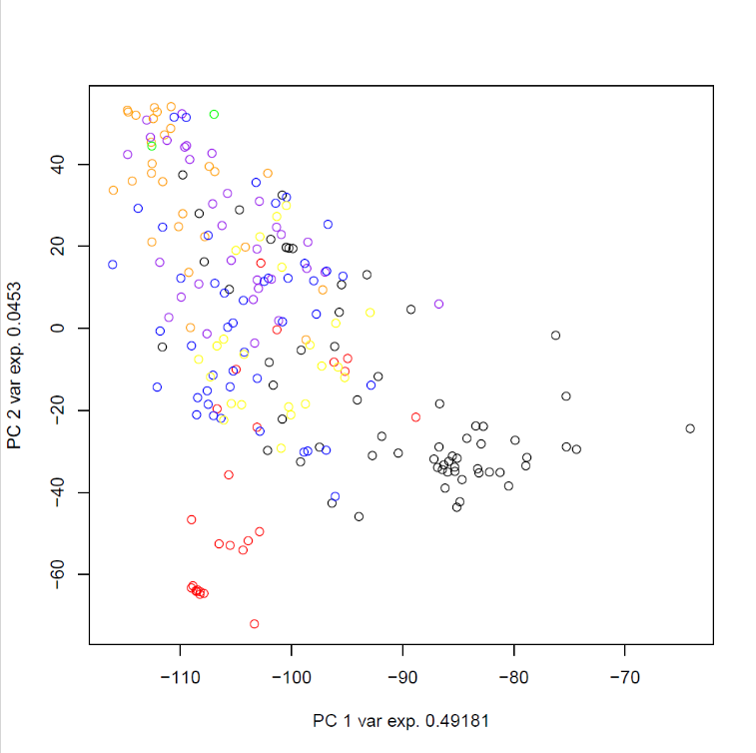
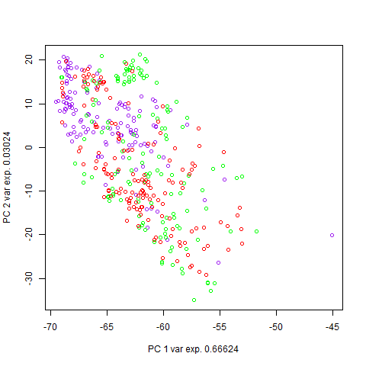
A
B

Figure 1. Principal component analysis (PCA) of 461 oat genotypes (A) and spring wheat (B) based genotyping data. The first two principal components explain the majority of genetic variation in the oat population.
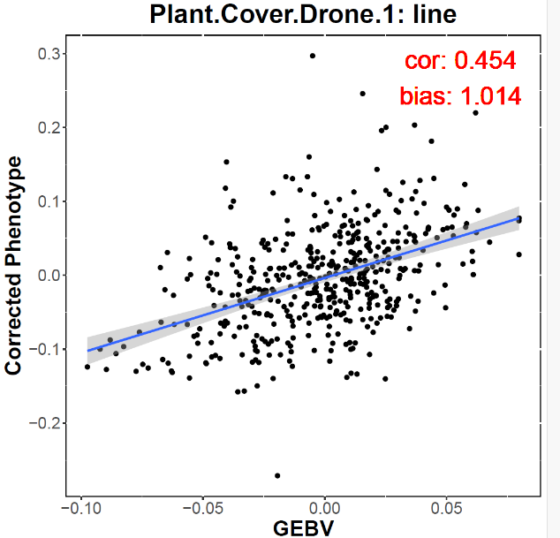

Figure 2. Prediction ability of genomic models as genome estimated breeding value (GEBV) for UAV-derived ground cover in oat measured in May.

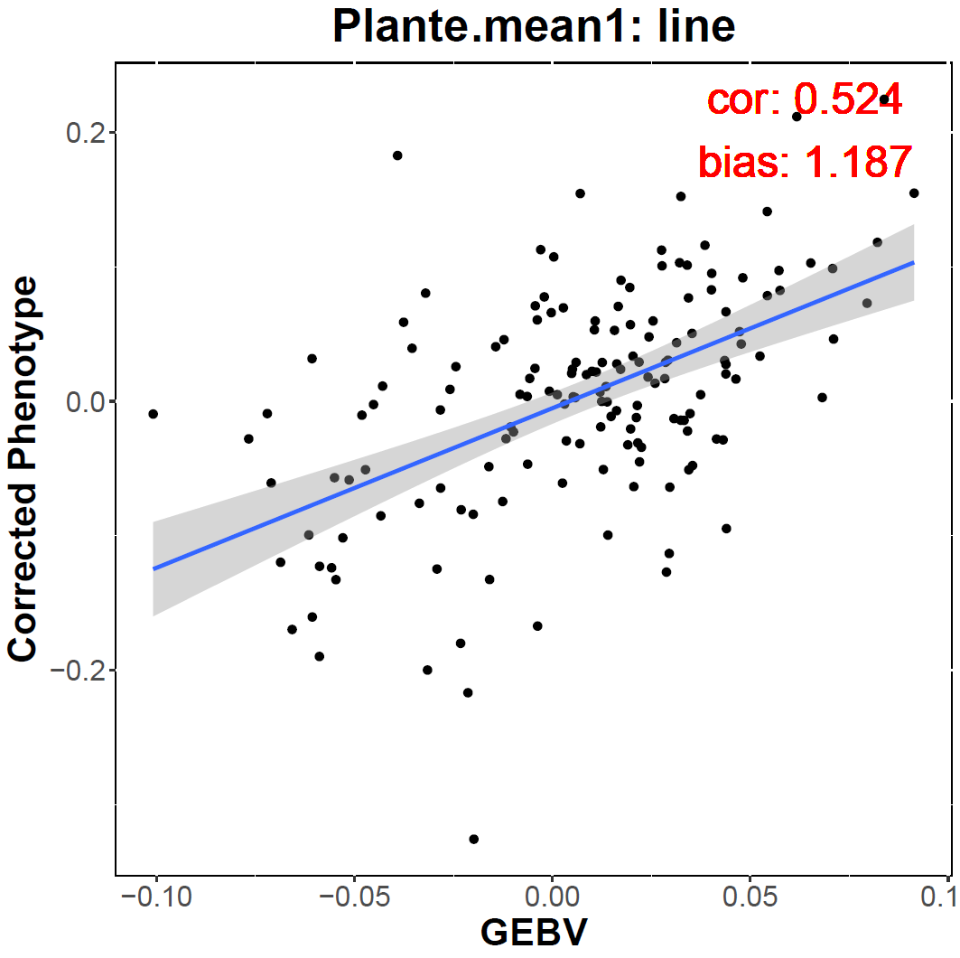

Figure 3. Prediction ability of genomic models as genome estimated breeding value (GEBV) for UAV-derived ground cover in oat measured in June. Higher prediction accuracy in May reflects larger phenotypic variation and stronger genetic signal at early canopy development stages.

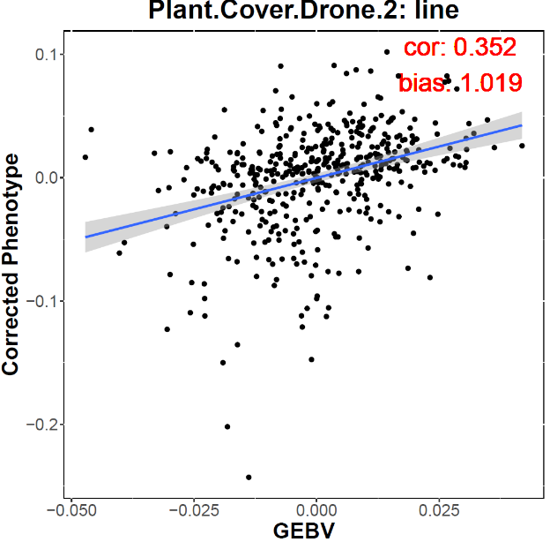

Figure 4. Prediction ability of genomic models as genome estimated breeding value (GEBV) for UAV-derived ground cover in spring wheat measured in May.

