Implementation Report
Project: Oatganic D2.2
D2.2. Easy-to-use DNA markers for high-throughput and effective screening of breeding lines for CCN resistance
FV4- Implementation of a Marker for Nematode Resistance in Oats
Organization: Nordic Seed

Summary

This report summarizes the implementation of an easy-to-use DNA marker for nematode resistance in oats within the Oatganic Fv4 project. The project involved identifying a significant genetic marker, converting it into a competitive allele-specific PCR (KASP) tool and integrating it into Nordic Seed's breeding program. This tool improves efficiency, cuts costs and speeds up the development of nematode-resistant oat varieties.1. Background

Nematode resistance is a key trait for sustainable oat breeding. The Oatganic project aimed to identify a DNA marker linked to resistance against cereal cyst nematodes, and to implement it as a practical selection tool for breeders.

2. Objectives
Identify a DNA marker associated with nematode resistance.
Convert the marker into a user-friendly KASP assay.
Implement the marker in Nordic Seed's breeding program.

3. Methodology
Each year, 100 oat breeding lines were phenotyped at Tystofte using a nematode resistance protocol. At the same time, the lines were genotyped using the Illumina 7K Oat SNP array to enable genome-wide association studies (GWAS). Significant SNPs were identified and the strongest marker was converted into a KASP assay.
See workflow diagram below:
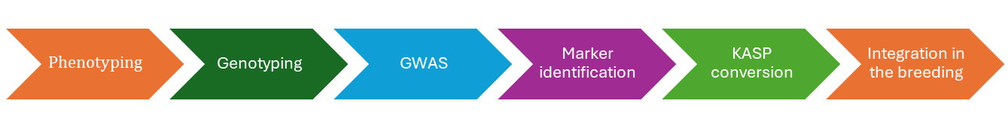

4. Results
GWAS revealed a significant association between resistance and SNP markers (Figure 1). The top marker was converted into a KASP assay and validated using 192 samples (see Figure 2). Allele X corresponded to resistance and Allele Y to susceptibility; heterozygotes were also distinguishable.
Figure 1: Manhattan plot showing SNP associations with nematode resistance.

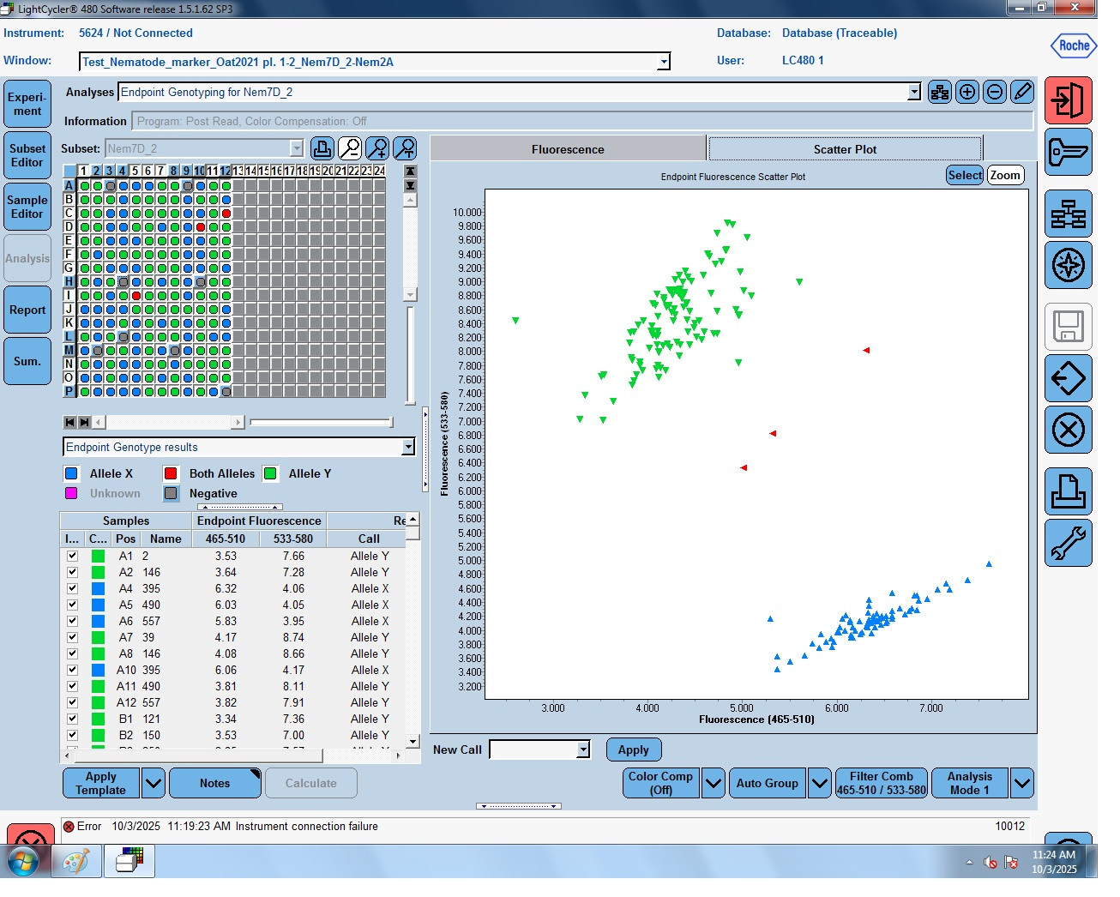Figure 2: KASP assay scatter plot of resistant, susceptible, and heterozygous lines.

5. Implementation

Nordic Seed has successfully integrated the KASP marker into its breeding pipelines. This enables the faster and more reliable selection of nematode-resistant oat lines, reducing reliance on the time-consuming process of phenotyping.

6. Discussion
When breeding for a trait, one of the important questions we must answer is what the nature of the trait is. In plant breeding, this involves selecting a genotype with the desired trait. A trait can be quantitative, which is controlled by many genes and shows a continuous distribution, or qualitative, which is typically controlled by one or a few genes and shows discrete classes. For instance, quantitative resistance to pathogens is usually polygenic, whereas major-gene resistance tends to segregate into distinct categories (Pilet-Nayel et al., 2017; Young, 1996). The phenotypic data received from Tystofte showed a quantitative pattern, with lines that were either resistant or susceptible. The GWAS analysis largely reflected this, as we observed one major association confirming the presence of a major quantitative trait locus (QTL). This type of trait architecture can speed up and simplify the selection process, since we can use one or a few markers to incorporate the QTL into a new genetic background (Merrick et al., 2021).
While the marker-based approach greatly improves breeding efficiency, phenotyping remains essential, particularly prior to the registration of new cultivars (St Clair, 2010). Future work could focus on obtaining higher-resolution marker coverage of the nematode QTL fragment to identify functional markers (or causal variants) that will further enhance selection precision.

7. Conclusion
The Oatganic project project successfully developed and implemented a KASP marker for nematode resistance in oats. This achievement supports sustainable agriculture and strengthens Nordic Seed’s breeding efficiency.

References
- KASP assay guidelines. Roche LC480 documentation: https://biosearchassets.biosearchtech.com/assetsv6/running-KASP-on-Roche-LC480.pdf?_gl=1*1w65a4a*_gcl_au*OTAyMzg1NjcuMTc1Njk4ODQ1OQ..*_up*MQ..*_gs*MQ..*_ga*MjA2MzI0NzA5MS4xNzU2OTg4NDU5*_ga_QLQ6ZQ021Q*czE3NTk0ODIyMTUkbzIkZzEkdDE3NTk0ODI0MTkkajIwJGwwJGgw&gclid=CjwKCAjw6P3GBhBVEiwAJPjmLvV4zoHimP16sF-NuPzZn9ftbxkdawbcPog8o5t7s7yg2i7kXaja2xoCsN4QAvD_BwE
- Merrick, L. F., Burke, A. B., Chen, X., & Carter, A. H. (2021). Breeding with major and minor genes: Genomic selection for quantitative disease resistance. Frontiers in Plant Science, 12:713667. https://doi.org/10.3389/fpls.2021.713667
- St.Clair, D. A. (2010). Quantitative disease resistance and quantitative resistance loci in breeding. Annual Review of Phytopathology, 48:247-268. https://doi.org/10.1146/annurev-phyto-080508-081904
- Pilet-Nayel, M.-L., Moury, B., Caffier, V., Montarry, J., Kerlan, M.-C., Fournet, S., Durel, C.-E. & Delourme, R. (2017). Quantitative Resistance to Plant Pathogens in Pyramiding Strategies for Durable Crop Protection. Frontiers in Plant Science, 8:1838. https://doi.org/10.3389/fpls.2017.01838
Tystofte Foundation. Protocol for nematode resistance screening. https://www.tystofte.dk/wp-content/uploads/2020/02/Protocol-for-nematode-resistance-screening-1.pdf
- Young, N. D. (1996). QTL mapping and quantitative disease resistance in plants. Annual Review of Phytopathology, 34:479-501. https://doi.org/10.1146/annurev.phyto.34.1.479

