WP2 - Training on organic cultivar testing
Module 8 – Participatory trial methodology
Unit 8.2 Designs for on-farm cultivar evaluation
Cooperation on ancient cereal landraces: The LIVESEED pilot in Hungary – video case study
Watch these four videos in order while considering the questions below. Write some notes below each question with your thoughts and ideas on each question. Be prepared to discuss these in the interactive session during this unit.
- Miért érdemes újra felfedezni az ősi 201gabonákat? - Rediscovery of ancient landrace cereals
- EGYÜTTMŰKÖDÉS A TÁJFAJTA ŐSGABONÁKÉRT - A LIVESEED pilot Magyarországon
- Organic winter wheat and ancient grain variety tests in Zseliz, Biocentrum organic farm, Slovakia
- Organic variety tests and product development at Csoroszlya Farm
- What are ancient grains and landraces?
- Why are they well-suited to organic systems? Include your own thoughts as well as those mentioned in the videos
Based on the need of the farmers compared to the industry
- How were the trials used in this project participatory? What inputs did the different actors along the value chain have to the trials?
- Describe the steps taken in testing and promoting ancient cereal landraces in the Magyarországon pilot.
- Describe the value chain included in the Csoroszlya Farm project? What different testing activities took place along the value chain? What were the positive outcomes of this approach? In what ways was this project similar to conventional variety testing? How was it different?

Images on OHM and plant diversity
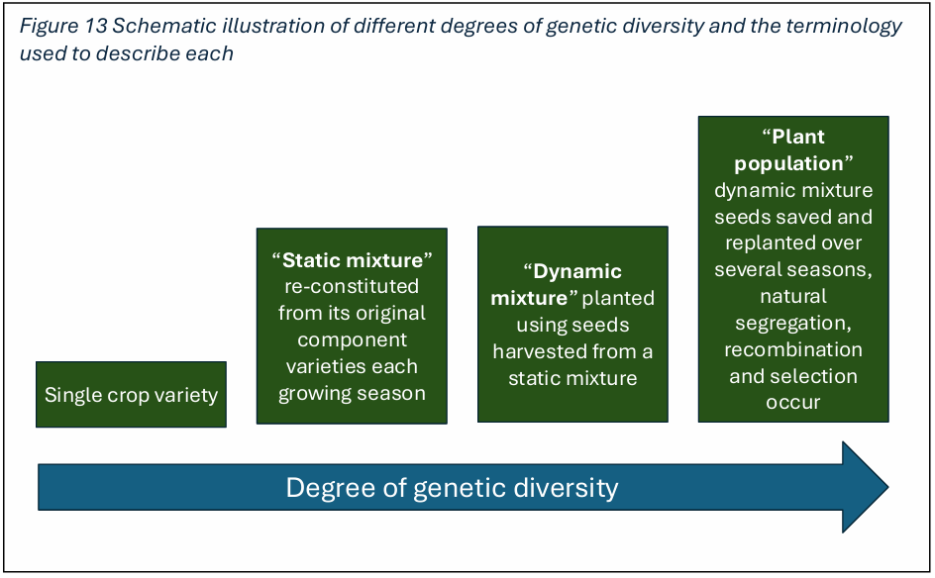
Cooper et al. (2025)
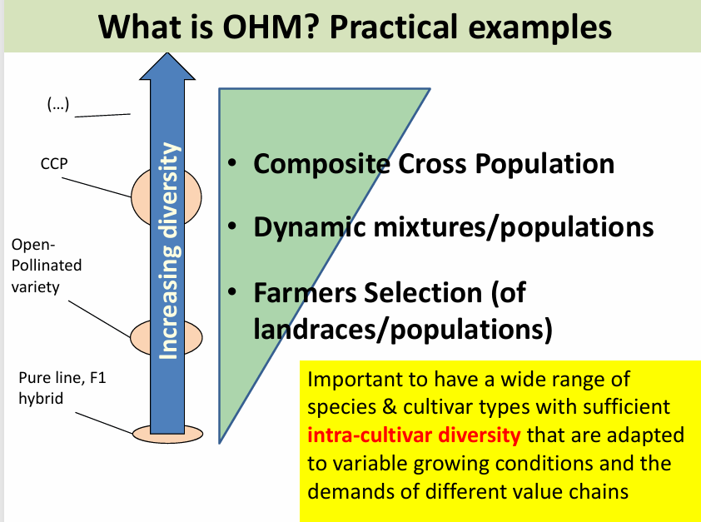
Matteo (2020)

