WP2 - Training on organic cultivar testing
Module 8 – Participatory trial methodology
Unit 8.2 Designs for on-farm cultivar evaluation
Cooperation on ancient cereal landraces: The LIVESEED pilot in Hungary – video case study
Watch these four videos in order while considering the questions below. Write some notes below each question with your thoughts and ideas on each question. Be prepared to discuss these in the interactive session during this unit.
- Miért érdemes újra felfedezni az ősi 201gabonákat? - Rediscovery of ancient landrace cereals
- EGYÜTTMŰKÖDÉS A TÁJFAJTA ŐSGABONÁKÉRT - A LIVESEED pilot Magyarországon
- Organic winter wheat and ancient grain variety tests in Zseliz, Biocentrum organic farm, Slovakia
- Organic variety tests and product development at Csoroszlya Farm
- What are ancient grains and landraces?
  - Encourage participants to find some definitions of ancient cereals/grains, landraces, populations, composite cross populations
- Why are they well-suited to organic systems? Include your own thoughts as well as those mentioned in the videos
  - Perfectly suited to local conditions; grow in areas unsuited to bread wheat production
  - Allow farmers to differentiate themselves in the market
  - others
- How were the trials used in this project participatory? What inputs did the different actors along the value chain have to the trials?
  - Workshop with farmers, millers and bakers to discuss how they can use ancient cereal landraces; also researchers; also regulators
  - Objectives for ancient cereal varieties were set by farmers; they were involved with scoring the varieties for selection using a 0-5 scale or they may have been directly involved in selection work; working together with the breeder towards common objectives
  - Bakers and millers had quality objectives
  - People in restaurants in Budapest needed local products
- Describe the steps taken in testing and promoting ancient cereal landraces in the Magyarországon pilot.
  - Samples of landraces were received from various gene banks in Switzerland and Hungary; also some modern varieties were included (2015 Year 1; Diversifood project)
  - Preliminary trials in one location to identify varieties suited to organic production (3 years in a row)
  - Multiplied selected varieties at one site in Hungary on-farm (2018)
  - Following year sowed them at other farms around the country (2019, 2020)
  - Used “participatory plant breeding” based on the needs of the farmers, with farmers involved in evaluating the cultivars
  - More distributed/decentralised trials in other habitats in following years, with farmer evaluation
- Describe the value chain included in the Csoroszlya Farm project? What different testing activities took place along the value chain? What were the positive outcomes of this approach? In what ways was this project similar to conventional variety testing? How was it different?
  - From production in the field through to milling of flour and baking of bread; restaurants; also involved OMKI and the research institute in Martonvasar
  - Also organic potato variety testing
  - And winter wheat testing – yields, quality,
  - Lots of small plots like in conventional testing
  - Have a small scale mill
  - So they are testing and innovating along the production chain

Images on OHM and plant diversity
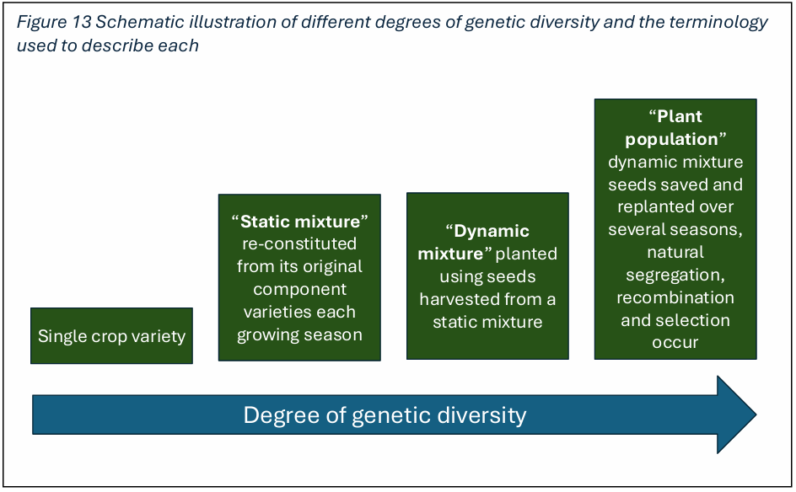
Cooper et al. (2025)
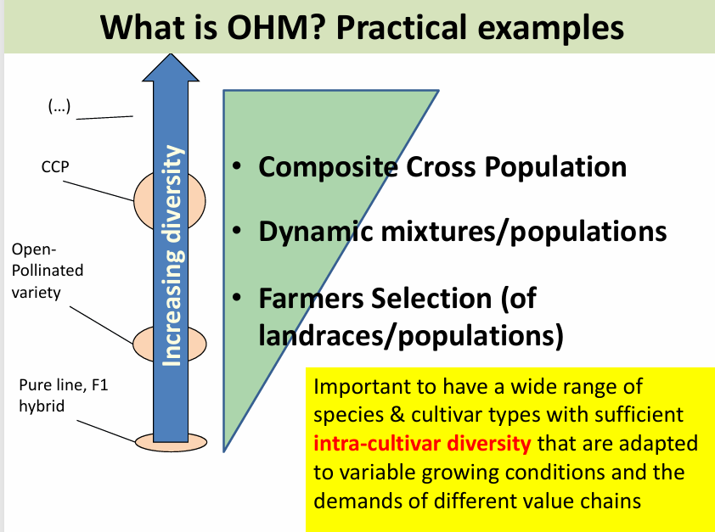
Matteo (2020)

