|  |  |  |  |  |
| --- | --- | --- | --- | --- |
| D3.1 | Document mix feeding with AR nauplii, and AR copepodites and AR adults versus rotifers and Artemia | UP2 | RUC | 01-03-2024 |

The classical way to perform live feeding in marine aquaculture hatcheries is by starting with rotifers and then later supplement them with different stages of Artemia. An alternative less used method is to initiate feeding with copepod nauplii, followed by copepodites and then lasts feeding with adult copepods (see figure 1).

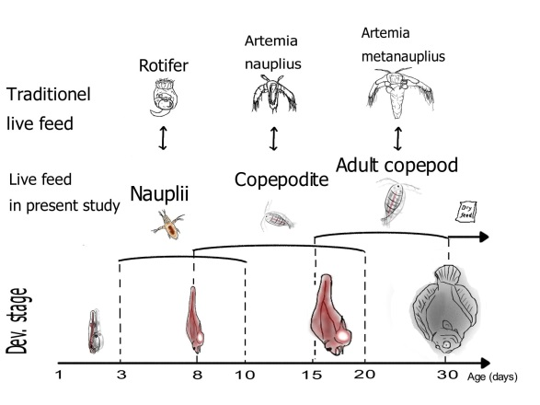

Figure 1 shows traditional live feeding with rotifers and subsequent Artemia versus live feeding with copepods (Abate et al., 2015).

In ORACLE-FISH we combined the feeding of rotifers, Artemia and copepods in a co-feeding experiment. To document the co-feeding we have chosen to use a preyfield to visulaise the feedings with the different feed items. The preyfield is used to make a visualization of the amount of prey available in each tank. It is created by taking three measurements each day, one in the morning before the prey is fed to each tank, then approximately 15 minutes after the first feeding, and then right before the second feeding in afternoon.

Et billede, der indeholder tekst, diagram, skærmbillede, Font/skrifttype

Indhold genereret af kunstig intelligens kan være forkert.

*Figure 2 Preyfield of of the tanks used for the experimental work in ORACLE-FISH to make a visualization of prey in the tank, during the entire experiment. It is measured in prey per mL (y-axis) and is measured each day (x-axis), between 12-07-2024 to 01-08-2024. Three types of prey are measured in the tank, rotifer (diamond shape), Copepod (triangle), and Artemia (circle). Measurements are made three times a day, one time in the morning before the feeding has happened (pink), approximately 15 minutes after the first feeding (purple), and the last time in the afternoon before the second feeding (blue).*

In the prey field it is desired to see that the prey being low in the morning, has an increase after the first feeding in the morning, and a decline in afternoon before the second feeding. When the prey is low in the morning, it indicates that all prey has either been eaten or removed by water flow, that way only enriched prey is available in the tank. An increase in the number of preys is wanted after the feeding, to indicate prey is available for the larvae. Later in the day a decrease is desired to observe, to again make sure enriched prey is in the tank for the larvae to eat.

Copepod (Triangle) was fed in three different life stages, being nauplii, copepodites and adults, but are all put into one category as copepod, where nauplii was fed in the beginning, copepodite was later added, and lastly adult copepod was added as well. Copepod could potentially be fed throughout the entire experiment, because all three life stages could fit size wise for the turbot larvae at different times.