D1.4 | AR copepod feeding trials with different organic food types, potential sidestreams from other industries | UF3 | RUC | 01-09-2023

The normal feeding procedure for feeding copepods and other aquaculture organisms involves initial feeding with microalgae. In marine aquaculture microalgae can curretly not be produced organic, hence one has to look for other options.
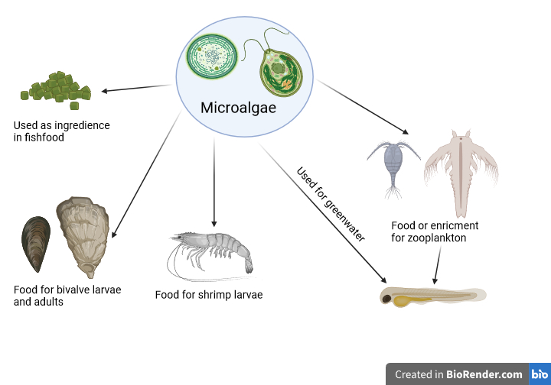
Figure 1: The classical marine food chain in marine aquaculture starting with microalgae that cannot for now be certified organic.

A recently newly discovered cyclopoid copepod has the ability to biosynthesis long changed fatty acids from lesser quality food. Hence the dependency of marine microalgae for food is no longer an issue with this copepod. Therefore, we investigated how to feed it from other food sources or side streams that comes from organic production.

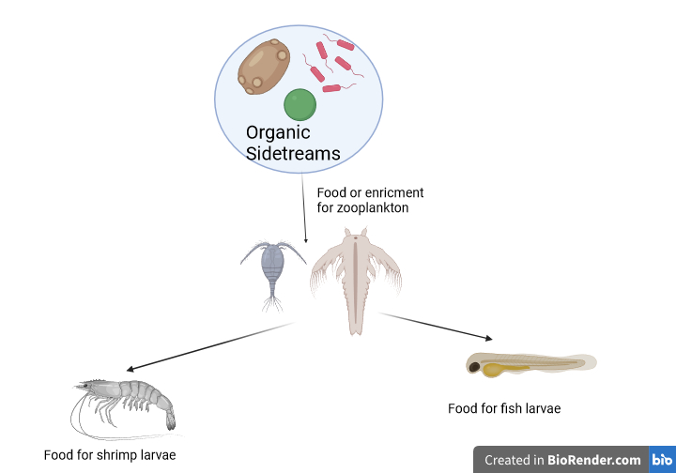
Figure 2: A new suggested feeding of a newly discovered cyclopoid copepod, that can feed from yeast, bacteria, or other organic side streams. Hence the principle for an organic live feed is present.

