Technical provision of organic farming in Russia: problems and prospects
V. Minin, A. Ustroev, E. Mbaiholoie & I. Subbotin
Institute for Engineering and Environmental Problems in Agricultural Production – IEEP Filtorovskoe shosse,3, p.o. Tiarlevo, St.Petersburg, 198625, Russia (minin.iamfe@mail.ru)
Farmers that currently are starting to engage in organic crop production are mostly oriented to conventional technologies, making small changes, and use the available agricultural tools. However, the crop environment in the organic field is characterized by physical, chemical and biological properties, which differ from more intensive farming. These conditions should be reflected in the selection of appropriate technological operations, which in turn fit into certain limitations.
Research on the adaptation of basic crop cultivation technologies to the requirements of organic production has started to carry out in the IEEP in 2015. The aim is to form a database of information on the processes taking place in organic agro-ecosystems under the influence of agricultural technologies and on this basis to develop the software system “Organic farmer assistance”, which will contain modern knowledge concerning organic crop production practices and will provide highly skilled remote support to farmers.
Sources of information include: special field experiments, laboratory experiments, as well as scientific literature.
The software system will allow to keep a record of the state of the farm and events, and on this basis to carry out activity planning. The state of the farm is the information about the condition of the soil, plants, weather; events are performed operations and state changes of farm objects. The system receives data in manual and automatic modes.
Based on the data on the state of the farm, planned activities and weather conditions, the system generates recommendations on timely measures aimed to improve the plant conditions and, as a result, increasing the yield (Picture).
To implement the system, an algorithm is necessary to respond to changing weather conditions and farm conditions and to suggest adjusting planned activities and adopting unplanned measures. The construction of such an algorithm is possible by creating a knowledge base and its "learning" by experienced agro experts. At the initial stage, decisions are made by agro-experts and the system, studying their reaction to various events, eventually forms a knowledge base of rules (knowledge base of rules), which, in the future, is able to make decisions on the formation of recommendations to the farmer.
For this purpose, the set of field experiments was established on the IEEP Experimental station. The design of the experiments will allow to collect the needed information to fill in the software.
Particular attention is given for following operations, which are important for organic crop production: mechanical tillage, application of organic fertilizers, weed and pest control.
We use tillage system with different depths for organic crop rotations: cereal crops - at depth of 12 - 16 cm, for vegetable crops and potatoes at depth of 22 - 24 cm by mould board plough. In the presence of strongly marked "subsoil layer" or waterproof horizon the subsoil shattering is conducted to a depth of 45 cm by chisel cultivator. Fall tillage is an effective way to control weeds, diseases and pests.
Promising is the use of technical means for the local application of solid manure in the furrow.
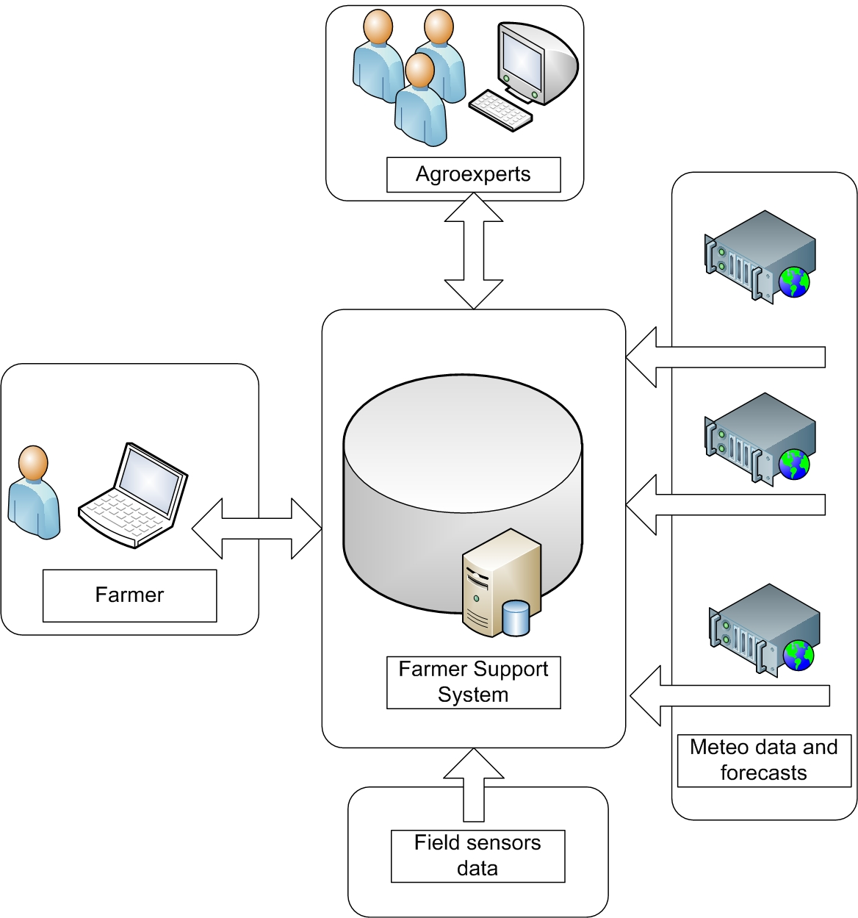

Picture. Software system “Organic farmer assistance”.

A particularly important task in organic agriculture is weed control. In addition to crop rotation, the previously developed and then half-forgotten cultivation of root crops in which was used ridge system and rotary harrows was used to handle the ridge slopes during the growing season. In the conditions of field experiments, the effectiveness of the use of the rotary harrows is estimated. In cooperation with scientists from the Russian Research Institute of Plant Protection the biological crop protection practices are investigated on the field experiments, also. In 2017 cooperative research on the IEEP Experimental Station is continuing.

Conclusions
There are a number of problems in the cultivation of organic agricultural plants, which restrain the production of agricultural products.
To solve these problems, efforts of representatives of different sciences should be combined, and the results of these efforts must be presented on the experimental field.
A good tool for organic farmers can be a Software that will collect and systematize the necessary knowledge, including practical results obtained in field experiments.

