Plant genetic resources in mountain oases of northern Oman

Gebauer, J., Luedeling, E., Hammer, K. & Buerkert, A.

Key words: crop diversity, genetic erosion, indigenous knowledge, multicropping systems

Abstract

In this study we assessed the genetic resources of three mountain oases in the al-Hajar range using a GIS-based field survey and farmer interviews. While arid conditions prevail throughout the mountain range, the different elevations of the oases in the Jabal al Akhdar mountains provide markedly differing agro-climatic conditions. Overall, 107 different crop species were identified belonging to 39 families. Species number was highest among fruits (33 spp.), followed by vegetables (24 spp.). Intensive irrigation allows cultivation of a broad range of species at all oases. However, the number of species varied significantly among sites. Fruit species diversity and homogeneity of the distribution of individual fruit species was highest at Balad Seet and lowest at Maqta, as indicated by respective Shannon indices of 1.00 and 0.39 and evenness values of 32% and 16%. Century plant, faba bean and lentil were identified as relict crops, supporting oral reports of past cultivation and providing evidence of genetic erosion. Overall greatest species similarity was found between Balad Seet and Al Jabal al Akhdar, as indicated by a Sørensen coefficient of similarity of 67%. Overall the study shows a location-specific but surprisingly diverse mosaic of crops in Omani mountain oases that merits further studies and conservation efforts.

Introduction

As in many other oil-producing countries in the Middle East, the economy and infrastructure of the Sultanate of Oman are developing at a rapid pace. Asphalt roads, housing and other amenities are being built to fulfil the needs of a fast-growing nation. In the mountain region of northern Oman, fascinating and sustainable agricultural systems have persisted for millennia in which agricultural and horticultural crops are intensively cultivated in traditional, mainly subsistence-oriented oasis systems (Nagieb et al. 2004, Buerkert et al. 2005). Fields consist of small man-made terrace systems, which are often squeezed between cliffs. Because of their green vegetation, pleasant microclimate, and availability of fresh water, the oases contrast strikingly with the dry and rough hyperarid landscape of northern Oman, and in recent years have gained increasing interests from scientists and tourists alike.

Materials and methods

Our survey was conducted in the Al-Hajar Mountains in northern Oman and comprised three spring-fed oases that have existed in this area for centuries to millennia and whose characteristics are listed in Table 1. Balad Seet and Al Jabal al Akhdar are located in the western Al-Hajar Mountains (Al Gharbi), while Maqta is situated in the eastern Al-Hajar Mountains (Ash Sharqi). Geo-referenced digital maps of the oases were produced from satellite images and low altitude aerial photography. The field work was conducted during August and September 2005 and March and April 2006. In the three oases each individual terrace was visited, resulting in a total of 1907 survey plots. In addition, three extensive palm groves at Balad Seet (8.88 ha) and 17 palm groves at Maqta (3.6 ha) were also studied in detail. Different farmers in each oasis were interviewed about the local names and primary uses of each species.

Table 1. Characteristics of the three study oases in northern Oman.
Characteristics | Balad Seet | Maqta | Al Jabal al Akhdar
Type of oasis | Core oasis | Scattered oasis | Core oasis
Altitude (m a.s.l.) | 950 – 1020 | 930 – 1180 | 1750 – 1930
Mean annual rainfall (mm) | 100 | 148ª | 336
Rainfall range (mm) | 30 – 240 | 42 – 255ª | 128 – 901
Mean Temperature (°C) | 23 | ^{b} | 19
Temperature range (°C) | 3 – 43 | ^{b} | -4^{c} – 32
Terraced land (ha) | 13.48 | 4.40 | 13.92
Number of springs | 12 | 22 | 2
Available water (m³ d⁻¹) | 601 | 115 | 856
Water m³ ha⁻¹ d⁻¹ | 44.8 | 25.6 | 65.6
Number of houses | 120 | 73 | 147
Number of inhabitants | 650 | 200 | 330
Number of households | 80 | 73 | 45
Number of survey plots | 385 agricultural fields and 3 palm groves | 130 agricultural fields and 17 palm groves | 375 agricultural fields and 1017 orchard terraces
ªBased on records from Ibra (2003 – 2005), 48 km west of Maqta,
^{b}no data available,
^{c}according to World Conservation Union (1987)

Results

In total, 107 different plant species belonging to 84 genera and 39 families were identified. Amongst the 39 families, Leguminosae (11 spp.), Gramineae (10 spp.), Rosaceae (7 spp.), Rutaceae (7 spp.) and Solanaceae (6 spp.) have the highest numbers of species. 91% of species are of exotic origin, while the remaining ones are indigenous to northern Oman. Of the 107 taxa found in the oases, 46 species are woody perennials and 61 are herbaceous crops. With a total of 85 cultivated species, Balad Seet was the oasis richest in species. The analysis of the species distribution among the three oases revealed that 27 species were common to Balad Seet, Maqta and Al Jabal al Akhdar (Figure 1). In general, fruits were the use category with the highest number of species (Figure 2). Fruit species diversity and homogeneity of the distribution of individual fruit species was highest at Balad Seet and lowest at Maqta as indicated by respective Shannon indices of 1.00 and 0.39 and evenness values of 32% and 16%. Century plant (Agave americana L.), faba bean (Vicia faba L. var. minor Peterm. em. Harz), and lentil (Lens culinaris Medik.) were identified as relict crops. Overall greatest species similarity was found between Balad Seet and Al Jabal al Akhdar, as indicated by a Sørensen coefficient of similarity of 67%.

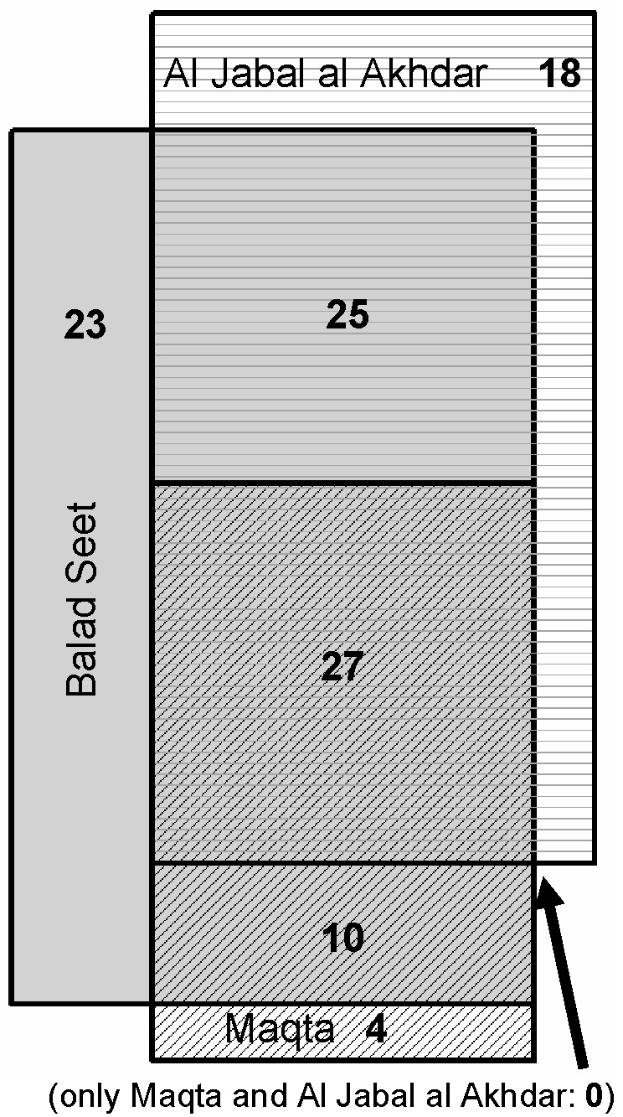 | 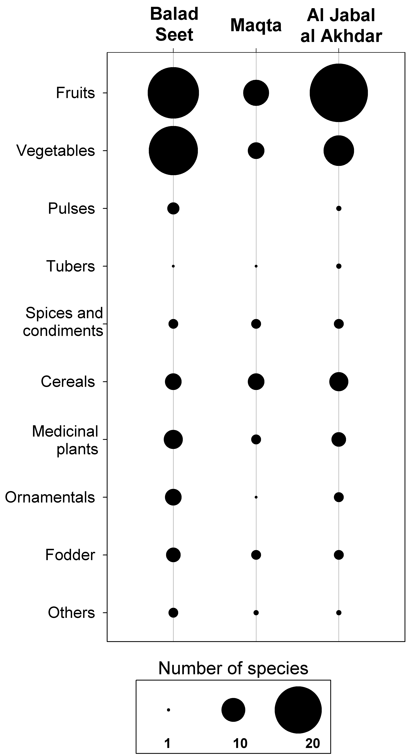
Figure 1: Species distribution among the three oases. The areas shown in the graph are proportional to the relative numbers of species. | Figure 2: Abundance of plant species of different use categories in the three oases in northern Oman.

Discussion

With a total of 107 different plant species, the number of crops was very high in comparison to other small-scale cropping systems under arid or semi-arid conditions (Hammer and Perrino 1985, Ceccolini 2002, Gebauer 2005). Fruit species richness was highest at Al Jabal al Akhdar, comprising 25 species. However, the Shannon indices indicated that species diversity was slightly higher at Balad Seet compared with Al Jabal al Akhdar. This is reflected in the highly heterogeneous distribution of individual fruit species at Al Jabal al Akhdar compared with Balad Seet, which translates to evenness values of 30% (Al Jabal al Akhdar) and 32% (Balad Seet). The occurrence of some individual plants in the fields and field borders supports the local oral records that some decades ago landraces of these species were widely cultivated. The complete loss of a species is only a last step in a long way of disappearance that reduces agricultural and horticultural biodiversity. Relict crops can also be considered as indicators of past genetic erosion (Hammer et al. 1999). According to the different climatic situations of the study oases (Table 1), some species were exclusively found under cooler or hotter conditions. This was especially obvious in the fruit category and is reflected by the Sørensen coefficients of similarity that were calculated to compare the three oases. The similarity between hot Maqta and cool Al Jabal al Akhdar is only 39%.

Conclusions

Germplasm collection activities, in situ conservation programs and interdisciplinary analysis of socioeconomic aspects or rural communications are urgently needed to better understand and preserve the heritage of these ancient agro-ecosystems.

Acknowledgments
The authors are indebted to Dr. Maher Nagieb for part of the data collection, the Agricultural Extension Center of the Ministry of Agriculture and Fisheries at Sayh Qatanah for general information about the oases on Al Jabal al Akhdar, to Sultan Qaboos University at Muscat for infrastructural support and to the Deutsche Forschungsgemeinschaft, DFG (BU1308) for funding.

References

Buerkert A., Nagieb M., Siebert S., Al-Maskri A., Khan I. (2005): Nutrient cycling and field-based partial nutrient balances in two mountain oases of Oman. Field Crops Res. 94:149-164.

Ceccolini L. (2002): The homegardens of Soqotra island, Yemen: an example of agroforestry approach to multiple land-use in an isolated location. Agrofor. Syst. 56:107-115.

Gebauer J. (2005): Plant species diversity of home gardens in El Obeid, Central Sudan. JARTS 106:97-103.

Hammer K. and Perrino P. (1985): A check-list of the cultivated plants of the Ghat oases. Kulturpflanze 33:269-286.

Hammer K., Laghetti G. und Perrino P. (1999): A checklist of the cultivated plants of Ustica (Italy). Genet. Resour. Crop Evol. 46:95-106.

Nagieb M., Siebert S., Luedeling E., Buerkert A., Häser J. (2004): Settlement history of mountain oasis in northern Oman – evidence from land-use and archaeological studies. Die Erde 135: 81-106.

This contribution is an extract of the recently published paper: Gebauer J., Luedeling E., Hammer K., Nagieb M. and Buerkert A. (2007): Mountain oases in northern Oman: an environment for evolution and in situ conservation of plant genetic resources. Genet. Resour. Crop Evol. 54: 465-481.
Department of Organic Agriculture and Agroecosystems Research in the Tropics and Subtropics, Institute of Crop Science, University of Kassel, Steinstr. 19, 37213 Witzenhausen, Germany, E-Mail tropcrops@uni-kassel.de, Internet http://www.uni-kassel.de/agrar/
As Above
Department of Agrobiodiversity, Institute of Crop Science, University of Kassel, Steinstr. 19, 37213 Witzenhausen, Germany, E-Mail khammer@wiz.uni-kassel.de, Internet http://www.uni-kassel.de/agrar/
As ²

