Sustainable increase of meat production on natural grasslands in Namibia
- research methodology and preliminary results -

Gerold Rahmann¹, Christian Hülsebusch², Judith Isele³ and Anita Idel⁴

¹ Thuenen-Institute of Organic Farming, Trenthorst, Germany, gerold.rahmann@ti.bund.de
² DITSL, German Institute of Tropical and Subtropical Agriculture, Witzenhausen, Germany
³ Springbockvley farm and Polytech of Namibia, Windhoek, Namibia
⁴ Company “Animal health und biodiversity”, Vogelsberg, Germany

Abstract
Improvement in grazing systems are necessary to increase the productivity and sustainability of grassland utilisation in semi-arid Africa. Changes in stock density and stocking rate as described in the concept of “Holistic Management” can be an option of improvement. This management concept has not been tested scientifically yet, despite farmers report good success. “Holistic Management” is carried out on the farm is Springbockvley in Namibia since 1993. Since 2014, the grazing system has been changed to prove the concept. Approximately 800 head of cattle and 3,000 head of sheep are used in different herd densities have been introduced on a 9,500 ha farm. The vegetation and the stock productivity are assessed for the first experimental year. The designed methodology seems to be applicable for a scientific assessment of some “Holistic Management” tools.
Introduction
Given the prominent role of herbivore livestock in grasslands, livestock must be addressed explicitly as a source of products such as meat, milk, hide, wool, fuel, manure and social security (Fresco & Steinfeld, 1998; Steinfeld et al. 2006) and as a major factor of ecological impact on the soils, the water and the vegetation of the pastures, which supply > 90% of livestock feed in the grassland-based livestock systems (Seré & Steinfeld, 1996).
Food production in the Southern African semi-arid countries like Namibia hinges to a large extent on effective management and utilization of the bulk of land, which consists of natural grassland, savannah systems, and rangeland-based farming systems with pockets of crop production (Bakker et al. 2006). Thus, the whole food system is essentially rangeland based and requires constant efforts to balance rangeland productivity with maintaining the natural resource base, including water saving technologies and strategies for combating or reversing the loss of land to desertification (Mills et al. 2005).
Due to the agro-ecological and socio-economic conditions combined with the land use history and past and current management practices, the grassland based food system in Namibia (as well as other semi-arid savanna areas of Africa) today faces the following problems, leading to a) loss of livelihoods, b) reduced ecosystem services and c) reduced development potential for remote, marginal areas.
Given the above problem setting, the main challenges for food systems based on grazing systems in semi-arid Africa (Scherr et al., 2010) lies in the sustainable improvement of natural grassland utilization starting out with the improvement of livestock management (production performance, health condition) and the integration of livestock and crop production (feed-manure chain). The utilization of the vast grasslands must maintain or even increase resource use efficiency (water, energy, nutrients, labour and land). The results will increase sustainable food production and profitability of rangeland use (food and income security). This is only possible if the results are understood, accepted, adapted, and applicable for farmers, stakeholders, and food policy decision makers.
Namibia is a semi-arid country with large savannah areas. The climate in Namibia is semi-arid (250-500 mm rainfall/year), with mono-modal distribution (rainy season Nov–Mar), and with high seasonal, annual, and spatial variability. The agro-ecological conditions can be taken as an example for similar areas throughout Africa.
Today, in Namibia livestock is kept in fenced pastures on farms, herded on communal farmland and non-farmland areas such as roadsides, forests, nature reserves, or kept as free roaming livestock close to the settlements (Zimmermann 2009). Resettlement programmes tried to lease farmland out to individuals, but fencing and maintenance of water infrastructure is expensive for the individual farmer.
Goal of the research:
The vast grassland systems in countries like Namibia need to be developed to become a more productive and well integrated part of the overall food system, and there is increasing evidence that there are new paradigms of improved livestock management and crop-livestock integration that can sustainably integrate crop and livestock operations and increase production (MAWF 2010).
Farmer’s experiences with different innovative rangeland and grazing management approaches such as Holistic Management (HM) will be taken as starting point to assess and develop novel and accepted grassland food systems for Africa. In the 1970s, the Holistic Management Approach (HM) was developed by Allan Savory (Savory & Butterfield, 1999) for a sustainable use of the vast semi-arid grasslands of Africa. The main principles of the HM approach are close to what in science is termed the “ecosystem services approach” (Fynn 2008).
So far, this approach lacks a thorough peer reviewed scientific evaluation. The “Springbockvley project” was launched in 2013 and by analyzing some minor aspects of the total approach wants to start a scientific assessment of HM to combat the future challenges in meat production on African savannah farming systems.
Questions for the research:
- Which methodology is suitable to measure biomass production and grazing days?
- How does the changing of stock densities (LU/ha) influence biomass production?
- How does the changing of stocking rates (LU/ha/a) influence biomass production?

Material and methodology
For the HM experiments, a 9,500 ha Organic cattle and sheep farm “Springbockvley” is used (Figure 1). The farm is located in the southern central part of Namibia, 180 km southeast of the capital Windhoek, on the Western edge of the typical Kalahari dune landscape but in almost completely flat countryside. With an average yearly rainfall of 260 mm Springbockvley is situated in an area of average production capacity which provides appropriate fodder for cattle and sheep alike. The farm has been managed according to the Holistic Management decision making framework since 1990 and is certified ‘Namibian Organic’ since 2013 (Isele 2014). In an inter-annual average, on the farm are about 800 Nguni cattle and 3,000 Damara sheep.
The Nguni cattle are an indigenous and robust breed and have an average live weight LW of 400 kg (thus, one cow is less than one Livestock Unit LU which is 450kg). The cows deliver every year a calf, which is suckling 6 to 8 months. Then calves are weaned and kept as fattening cattle in a separate “oxen herd”. Between weaning and slaughtering at 3 years of age they gain about 300 kg and by then have an average live weight of 450 kg (1 LU). Taking into account different ages, sex and performance, the average live weight of the total cattle herd is considered to be 300 kg per total head of cattle including calves. The fat tailed Damara sheep are also a hardy indigenous breed. The ewes have an average live weight of 45 kg (10 ewes are one LU) and deliver about 1 lamb per year (natural lambing peak is May to August). The average live weight of the total sheep flock is considered to be 35 kg per ewe including lambs. The average annual total live weight of all livestock depends on the available fodder, and since 2005 varied between 235 to 415 tons, which is about 25-44 kg LW per hectare (see Figure 2).
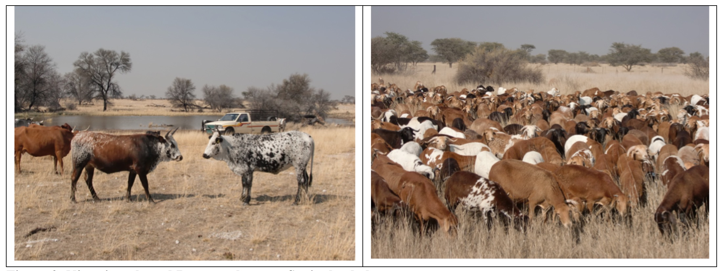
Figure 2: Nguni cattle and Damara sheep on Springbockvley
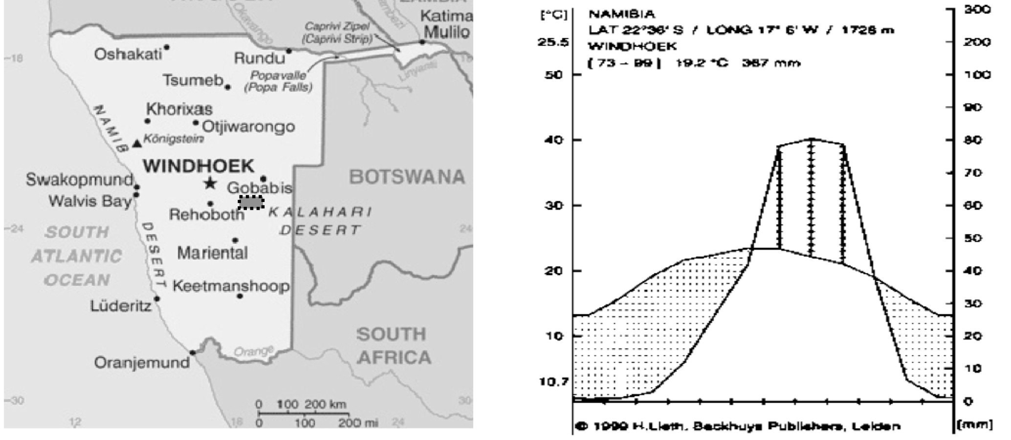

Figure 1: Location of the Springbockvley farm and climate conditions in the region

Different stocking densities and stocking rates will be taken as starting point to assess and develop sustainable stock densities and stocking rates on grassland in Namibia. In 2013, Springbockvley has changed the grazing management system (4 herds rotated in 4 farm sections) into a full farm rotation with 3 herds: cows, oxen and sheep (see figure 3). The three herds are in following structure (with inter- and intra-annual changes, recent figures March 2015) and sum up to a total live weight of 414,250 kg (920.6 LU) and a resulting stocking rate on the farm of 43.6 kg per hectare:
- Cows herd: consisting of 505 cattle: 134 cows with small calves, 123 pregnant cows that have recently weaned their calves, 40 pregnant heifers, 70 heifers ready to be bred, 15 bulls with an average live weight of 3,000 kg and a total live weight of 151,500 kg (336.7 LU).
- Ox herd: consisting of 308 cattle: 194 oxen from weaning to slaughter age, 52 weaning heifers and 54 culled cows with 8 calves with an average live weight of 3000 kg and a total live weight of 92,400 kg (205.3 LU).
- Sheep flock: consisting of 3,950 sheep and 107 cattle: 1,950 ewes with lambs, 50 rams with an average live weight of 35 kg and a total live weight of 138,250 kg (307.2 LU) plus 107 young bulls from weaning to slaughtering age with and average live weight of 300 kg and a total live weight of 32,100 kg (71.3 LU). Thus the total Sheep flock and bulls her has an average live weight of 170,350 kg (378.5 LU).

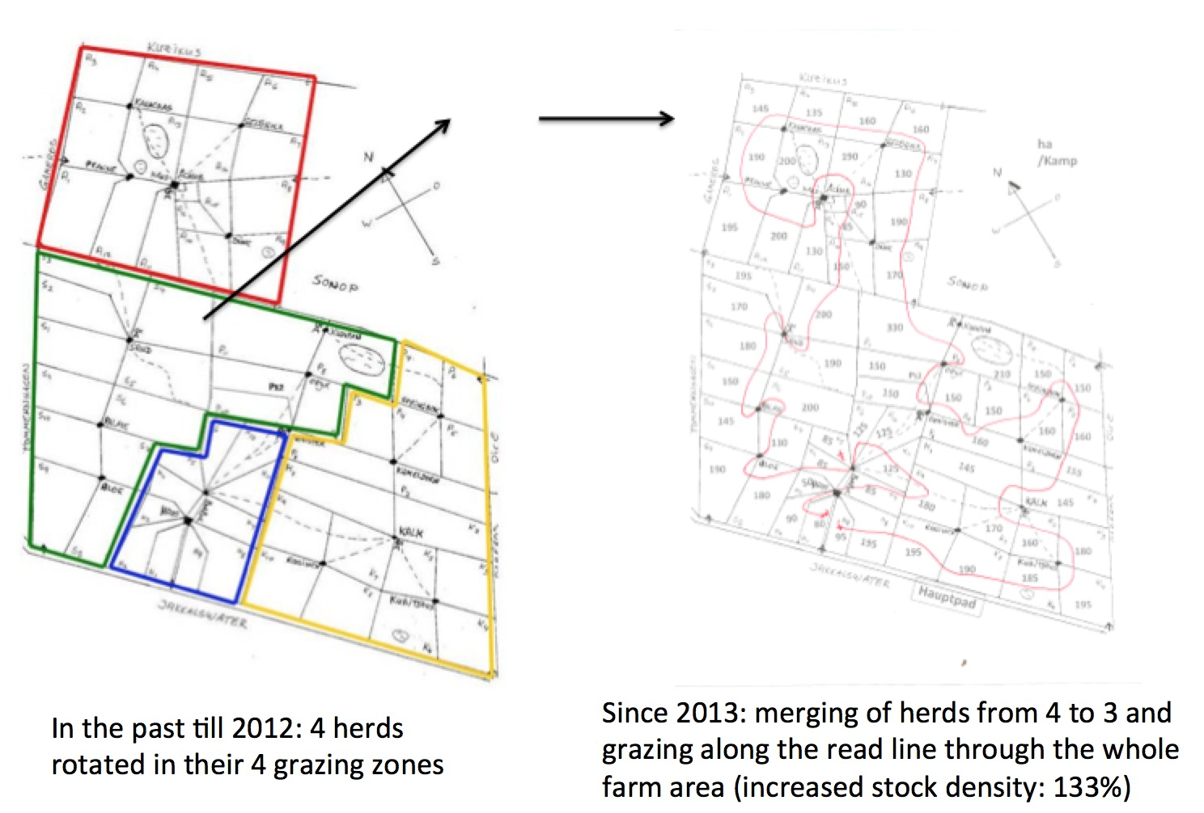

Figure 3: Grazing management system with the three herds of cows, oxen and sheep on Springbockvley
The changes of herd composition and grazing management do not increase the overall stocking rate, but the stocking density (about 133% compared to the conditions before 2013). The expected impact is further increase of biomass production, consequently an increase in carrying capacity and thus ultimately more meat production per ha, or, alternatively higher stability in the case of droughts (more fodder available for dry periods).
All three herds will follow the „red grazing line“ on the farm and provide average resting periods between 80 and 100 days for every grazed plot during the non-growing season and average recovery periods between 100 and 140 days during the growing season. That means, that every herd/flock will have grazed every paddock approximately 1 to 1,3 times a year. Grazing plans are drawn up according to Holistic Management Planned Grazing after an annual estimation of animal consumable biomass (grazing days per ha) for every paddock using different methodologies. For the project two stocking and thus grazing treatment variations will be integrated:

- HighSD: Increased stocking density (The paddock will be subdivided with a mobile electric fence into a number of parcels equivalent to the planned days for the respective camp to be grazed in the current selection. Every day a new parcel will be opened for the herd to graze.)
- DoubleSR: Increased stocking rate (The paddock will be grazed for twice the duration of planned days for the camp to be grazed.)
- Control: These experimental grazing variations will be compared with the current system of stock density and stocking rate.

For these experiments, four replications have been selected on the farm. The goal of the research is to prove if these changes can be measured scientifically. The experiment will be done for 3 years, from May 2014 to May 2017.

Table 1: Experimental plots for different stocking rates and densities
 | DoubleSR | HighSD | Control
Replication 1: “H” (House) | “H9” (95 ha) | “H2” (90 ha) | “H1” (80 ha)
Replication 2: “S” (Sand) | “S7“ (130 ha) | “S11” (150 ha) | “S10” (145 ha)
Replication 3: “A” (Achab) | “A3” (145 ha) | “A6” (160 ha) | “A5” (160 ha)
Replication 4: “P” (Pan) | “P9” (150 ha) | “P4” (160 ha) | “P3” (150 ha)

The variation of the herd management will be done while the routine grazing modus, following the „red grazing line“. There will be no fixing of the date, when the herds enter the paddock. The herds will enter each paddock in compliance with the grazing plan designed as per description above. The fodder availability expressed in grazing days per ha will be assessed in May of each year. The selected paddocks will be managed according to the grazing plan, and this will be assessed. The „red line“ has been modified so that the herds/flocks will always graze two normal paddocks (managed according to the current grazing regime) before they enter a treatment paddock (increased stocking density or double stocking rate). This is deemed necessary as an adaptation period for the animals before entering treatment. The second of the normal paddocks between two treatments serves as control (Table 1 and map above).
From May 2014 until February 2015, the different herds have utilized the control and treatment plots in following time and densities (Table 2).

Table 2: Grazing management from May 2014 until February 2015
Repli- |  | Grazing May - July 2014 |  | Grazing Aug - Oct 2014 |  | Grazing Dec 2014 - Feb 2015
cation | Treatment | from … to | Herd | from … to | Herd | from … to | Herd
H1 | Control | 31.5.-2.6. | Cow herd* (400 cattle: total  120 tons  LW) | 28.-30.8. | Sheep herd** (3,600 sheep, 88 bulls: total 152 tons LW) | 11.-13.12. | Oxen herd*** (268 cattle:  total 80.4 tons LW)
H2 | HighSD | 2.-5.6. |  | 30.8.-2.9. |  | 13.-16.12.
H9 | DoubleSR | 12.-17.5. |  | 19.-25.8. |  | 4.-7.12.
S10 | Control | 10.-15.7. | Cow herd  (460 cattle:  total 138 tons LW) | 18.-23.10. | Sheep herd (3,800 sheep, 90 bulls: total 160 tons LW) | 11.-19.2. | Cow herd  (513 cattle:  total 154 tons LW)
S11 | HighSD | 15.-20.7. |  | 23.-28.10. |  | 19.-27.2.
S7 | DoubleSR | 27.6.-5.7. |  | 5.-9./11.-13.10. |  | 24.1.-3.2.
A5 | Control | 16.-21.7. | Oxen herd  (285 cattle:  total 85.5 tons LW) | 15.-20.10. | Cow herd  (419 cattle:  total 125.7 tons LW) | 5.-12.2. | Sheep herd (3,900 sheep, 121 bulls: 172 tons LW)
A6 | HighSD | 21.-26.7. |  | 20.-25.10. |  | 12.-18.2.
A3 | DoubleSR | 1.-11.7. |  | 1.-11.10. |  | 16.-30.1.
P3 | Control | 27.-5.-2.6. | Sheep herd (3200 sheep, 67 bulls: 132 tons LW) | 20.-25.9. | Oxen herd  (332 cattle:  99.6 tons  LW) | 22.-27.12. | Cow herd  (408 cattle: 122.4 tons  LW)
P4 | HighSD | 2.-6.6. |  | 25.-30.9. |  | 27.12.-3.1.
P9 | DoubleSR | 12.-22.5. |  | 5.-15.9. |  | 6.-16.12.
* Cow herd: breeding female cattle (cows, heifers and calves) with an average LW of 300 kg,
** Sheep herd = on breeding unit of ewes, rams and lambs (average LW of 35 kg) and breeding bulls (300 kg LW).
*** Oxen herd = fattening cattle (oxen, finished cows, fattening heifers) with an average LW of 300 kg.

Livestock assessment
- Cattle: All cattle are weighed once every year during the compulsory vaccination routine (Anthrax, Brucella).The livestock is weighed always while they are close to the weigh scale (water point Mahali, 500 m east of farm house).
- Sheep: A randomly selected group of sheep will be weighed: clustered by age and function (lambs <6 months; lambs 6-12 months; adult sheep > 1 year). The average number per group should be 50 animals. The result is assumed to be the average weight of all the other sheep in that respective same cluster.
- All cattle and sheep will be estimated in live weight as soon as they enter the experimental paddocks to have the most accurate live weight of the herds.
- The wild game will be assessed for the experimental paddocks (in estimated kg live weight).
- All routinely gathered weight data of livestock (live weight, carcass weight, birth weights) will be included in the data base to improve the data as much as possible.
- Births weights of calves and lambs will be recorded randomly (50 calves and 200 lambs per season).
- All livestock records will be included in the study: losses, sales and purchases, livestock diseases, treatments, calvings, etc.

Vegetation assessment
The main proof of the herd management will be on the assessment of the vegetation (Glatzle 1990). Because it is not clear, which methodology of biomass measurements can be used, a tool test (methodology assessment) has been included in the study. Seven different methodologies have been chosen for comparison:
- Platemeter test: Transect walk with a platemeter on all treatment and control paddocks. Done every May from corner to the opposite (diagonal) corner (between 1 and 2 km), every second step one measurement. The inter-annual comparison of the „average biomass height“ will be the indication of growth and biomass.
- Vegetation cut test: on 200 m randomly chosen transect, not closer than 100 m from the paddock fences or other unusual parts of the paddock. Every 20 m a 1 sqm vegetation cut (10 samples per plot) will be done and can be assessed (biodiversity, biomass, feeding value). This will be done every May.
- Vegetation estimation test: on a 50x50 m (2,500 sqm) permanently defined and marked „Estimation“-parcel (minimum 100 m apart from the paddock fence and special parts of the paddock) the methodologies of
  - „Klapp“ (Biodiversity and biomass estimation combined with special values: feeding value, grazing tolerance etc) and
  - „Braun Blanquet“ (Biodiversity and coverage of vegetation, bare land and dead material).
These methodologies will be done according to international standards of grassland estimations. The assessment will be done every May and just before and after each grazing event of the treatment and control paddocks.
- Transect test: on a 200 m quadrant line (the borders of the parcels in test 3) qualitative biomass assessment (occurrence and abundance of plant species) will be assessed.
How and when to be done: Every meter along the 200 m line the a) alive plant, b) dead plant, c) litter and d) bare soil
will be assessed (where the line touches on ground every m). This will be done in May each year.
- Picture test: every year, a transect line picture will be done. Comparison over the years.
How and when to be done: Every May and before and after the grazing a picture is taken always from the main marking pole in the direction of the two adjacent marking poles (50 m distance).
- Quadrant test: in the corner of the parcel from test 3, a visual estimation will be done on how big one grazing day would be (estimation of the lateral length of the square that feeds one LU for one day). To be done every May and before and after each grazing event.
- STAC method test: the two diagonals of the parcel from test 3 will be measured according to the STAC method. Every second footfall the average bulk biomass will be estimated in grazing days per hectare. The average of all values will be taken as estimated grazing days per hectare for the area. To be done every May and before and after each grazing event.

The comparison of these seven very different vegetation tests is assumed to allow answers about the best, cheapest and most useable measure (also for farmers) to assess the vegetation coverage, biomass and grazing days estimations in heterogeneous semi-arid savannah-type grasslands. Although test 6 and 7 are rather subjective estimation methods they have been included in the tool test in order to reflect the necessity to provide reliable means to assess biomass in day to day farming life of practitioners.

Results
The meat production on Springbockvley was assessed by farm records from 1994 till 2012, the last year before converting towards organic farming and the novel grazing management system. The rainfall was uncertain and between 61 mm (1995) and 680 mm per year (2011), surprisingly with a slight increasing trend. The stocking rate and the meat production do follow the annual rainfall performance (Figure 4). The stocking rate varied between 17 (1995) and 43 kg live weight (2012) per hectare, the meat production (live weight) per hectare between 5.3 (1995) and 15.2 kg (2013).

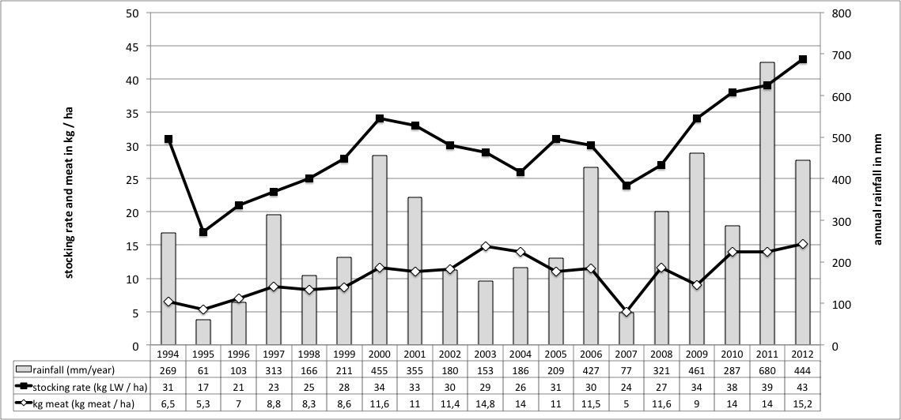
Figure 4: Development of annual stocking rate, annual rainfall and meat production (kg/ha LW) 1994 - 2012

The average number of different plant species on the different experimental grazing was assessed on 2,500 sqm plots before and after the three herds of cow herd, oxen and sheep have used the plots (Table 3).The total average number of species found in sampling plots before grazing events is higher than after grazing events. This applies to all grazing treatments, double stocking rate, high density and normal grazing respectively.

Table 3: Average number of different plant species found in sampling plots before (pre-assessment) and after (post-assessment) grazing treatments
 | Cows |  | Oxen |  | Sheep |  | Average
 | Before | After | Before | After | Before | After | Before | After
DoubleSR | 9.3 | 8.7 | 10.0 | 8.3 | 10.7 | 9.7 | 9.9 | 8.9
HighSD | 12.0 | 12.7 | 13.0 | 10.0 | 10.7 | 9.0 | 11.8 | 10.6
Control | 12.7 | 11.7 | 10.7 | 9.0 | 10.3 | 11.3 | 11.2 | 10.9
DoubleSR: double stocking rate; HighSD – high stocking density; Control: normal grazing; measured with method “Brown Blanquet” after grazing with the herd of cows, oxen and sheep respectively. Average across four replications“A”, “H”, “P” and “S”.

Table 4: Potential grazing days per hectare (GD/ha) estimated by means of the Quadrant method (see above, tool test 6) in sampling plots before and after grazing treatments
 | Cows |  | Oxen |  | Sheep
 | before | after | before | after | before | after
DoubleSR
A | 20.7 | 18.9 | 44.4 | 25.0 | n.a. | n.a.
H | 25.0 | 29.2 | 6.9 | 5.7 | 25.0 | 13.7
P | 11.1 | n.a. | 14.8 | 10.4 | 30.9 | 13.7
S | 100.0 | 39.1 | n.a. | n.a. | 59.2 | 27.7
HighSD
A | 14.8 | 14.8 | 34.6 | 17.4 | n.a. | n.a.
H | 44.4 | 20.7 | n.a. | n.a. | 14.8 | 16.0
P | n.a. | n.a. | 18.9 | 17.4 | 30.9 | 25.0
S | 51.0 | 30.9 | n.a. | n.a. | 20.7 | 20.7
Control
A | 34.6 | 30.9 | 39,1 | 39,1 | n.a. | n.a.
H | 11.1 | 16.0 | 13,7 | n.a. | 16.0 | 18.9
P | n.a. | n.a. | 27,7 | 18,9 | 34.6 | 44.4
S | 69.4 | 34.6 | n.a. | n.a. | 34.6 | 30.9
DoubleSR = double stocking rate; HighSD = high density; Control = normal grazing; across four replications “A”, “H”, “P” and “S”.

Conclusion
The grazing systems in the semi-arid savannah area of Namibia are not well managed. Changes in stock density and stocking rate as described in the concept of “Holistic Management” could be an option of improvement. This management tools have not been tested scientifically yet, despite farmers reported good success. Different herd densities have been introduced on a 9,500 ha farm in Namibia in 2014 to prove the promises of the Holistic Management. The vegetation and the stock productivity have been assessed. The methodology seems to be applicable for a scientific assessment of Holistic Management.

References
Bakker E, Ritchie ME, Olff H, Milchunas D, Knops JMH 2006. Herbivore impact on grassland plant diversity depends on habitat productivity and herbivore size. Ecology Letters 9:780-788.
Fresco LO, Steinfeld H 1998. A food security perspective to livestock and the environment. In: Nell AJ (ed.) Proc. International Conference on Livestock and the Environment, Wageningen (Netherlands), 16-20 Jun 1997. FAO, Rome (Italy), pp. 5-12.
Fynn RWS 2008. Savory insights – is rangeland science due for a paradigm shift?. Grassroots: Bulletin of the Grassland Society of Southern Africa, September 2008, Vol 8/3:25-37.
Glatzle, A 1990. Weidewirtschaft der Tropen und Subtropen. Ulmer Verlag, Stuttgart
Isele, J 2014. Bridging drought. Resilience in Rangeland Management in Times of Climate Change. Proceedings of the practitioner track of the OWC 2014, Istanbul
MAWF 2010. National Rangeland Management Strategy. Policy for Namibia. Windhoek
Mills AJ, Fey MV 2005. Interactive response of herbivores, soils and vegetation to annual burning in a South African savannah. Austral Ecology 30:435-444
Savory A, Butterfield J 1999. Holistic Management - A New Framework for Decision Making. Island Press, Washington DC, USA. 616p.
Scherr SJ, Wallace C, Buck L 2010. Agricultural Innovation for Food Security and Poverty Reduction in the 21st Century: Issues for Africa and the World. Issues Paper for State of the World 2011: Innovations that Nourish the Planet. Ecoagriculture Partners, Washington, D.C., www.worldwatch.org/files/pdf/ SOW11 %20Issues%20Paper_Full%20Version_Fin al.pdf
Seré C, Steinfeld H 1996. World livestock production systems: current status, issues and trends. FAO Animal Production and Health Paper 127, Rome, 390p.
Steinfeld H, Gerber P, Wassenaar T, Castel V, Rosales M, de Haan C 2006. Livestock’s Long Shadow: Environmental Issues and Options. FAO, Rome, Italy.
Zimmermann I 2009. Causes and consequences of fenceline contrasts in Namibian rangeland. Ph.D. Thesis, University of the Free State.

