Effect of arbuscular mycorrhiza fungi
on growth and development of
onion and wild relatives

Olga E. Scholten, Guillermo Galvan-Vivero, Karin Burger-Meijer, Jacqueline Baar, Chris Kik

Abstract – Arbuscular mycorrhizal fungi play an important role in the uptake of nutrients and water from soil. Onions, Allium cepa L., are plants with a shallow root system. As a result, onion plants need a lot of fertiziler for their growth. Furthermore, onion plants are sensitive to drought. The aim of the current research project is to study the beneficial effect of mycorrhizal fungi on the growth and development of Allium species and to determine whether it is possible to improve onions for mycorrhizal responsiveness by means of breeding.

Introduction
Arbuscular mycorrhizal fungi (AMF) are fungi that occur naturally in soil. These fungi play an important role in plant growth since they contribute to the uptake of nutrients and water from soils (Ryan and Graham, 2002).
Onion (Allium cepa L.) is one of the leading vegetable crops worldwide. Also in Europe, the crop is of considerable economic importance. The global distribution of onions is due to the universal acceptance for food and condiment, but certainly not due to its simplicity of growing. In fact, onion is a crop that is difficult to grow and one of the major challenges is to provide onion plants with sufficient nutrients (Brewster, 1994).
A massive amount of chemical fertilizer is needed to grow onions. The sustainability of large chemical fertilizer is highly questioned and growing onions in low-input systems with reduced fertilizer inputs are gaining ground. For low-input systems, plants have to be good nutrient scavengers. Therefore, productivity and stability of onion production in systems with reduced fertilizer input can be problematic (De Melo, 2003). The root systems of onions consist of superficial roots that are rarely branched and lack root hairs (Portas, 1973; Greenwood et al, 1982). This root system is very inefficient in its uptake capacity of water and nutrients such as phosphate (Wininger et al, 2003; De Melo, 2003).
From earlier studies, it is known that onion plants can associate with mycorrhizal fungi, the arbuscular mycorrhizal fungi (AMF) (Stribley, 1990; Charron et al., 2001). Application of AMF in organic fields with reduced fertilizer input and no use of fungicides resulted in yield increases of Allium fistulosum between 50 and 60% and significant increase of soil rooting area (De Melo, 2003).
The aim of the research was to study the beneficial effect of arbuscular mycorrhizal fungi on the growth and development of Allium species and to determine whether it is possible to improve onions for mycorrhizal responsiveness by means of breeding.

Materials and Methods
Plant materials and AMF
Pant materials consisted of six onion cultivars: Accent, Durito, Hyduro, Hyfort, Jumbo and Summit, and three wild relatives of onion: A. fistulosum, A. roylei and A. galanthum. AMF species Glomus mosseae was obtained from Biorize, France and multiplied on leek roots. A second AMF species, G. intraradices, was kindly provided by Dr. Y. Kapulnik, Volcani Centre Israel.

Greenhouse and field experiments
For greenhouse experiments, seedlings were transplanted into 5l pots containing a mixture of sterilized organic clay soil, sand and perlite (v:v:v 12:2:2). Field trials were performed at an organic farm in the Netherlands. AMF was added to the plant hole just before transplanting. In control treatments no AMF was added.

Evaluations
During the growing season and also at harvest we measured several characteristics of the plants, such as: plant height, number of leaves, fresh and dry weight, dry matter content, fresh and dry weight of the onion bulbs and neck diameter of the bulbs.

Results and Discussion
Greenhouse experiment
Significant differences were found between plants grown in pots without AMF and plants grown with AMF (Figure 1). All onion cultivars and also the wild relatives responded positively for plant height, fresh and dry weight after addition of AMF. The largest increase for these traits was found for plants of Allium cepa en A. fistulosum (Figure 2: example for plant height). Between cultivars also significant differences were observed when we compared treatments with and without AMF for example for plant heights (Figure 3). We did not observe any difference in plant development and growth between the use of G. mosseae in comparison to the use of G. intraradices.

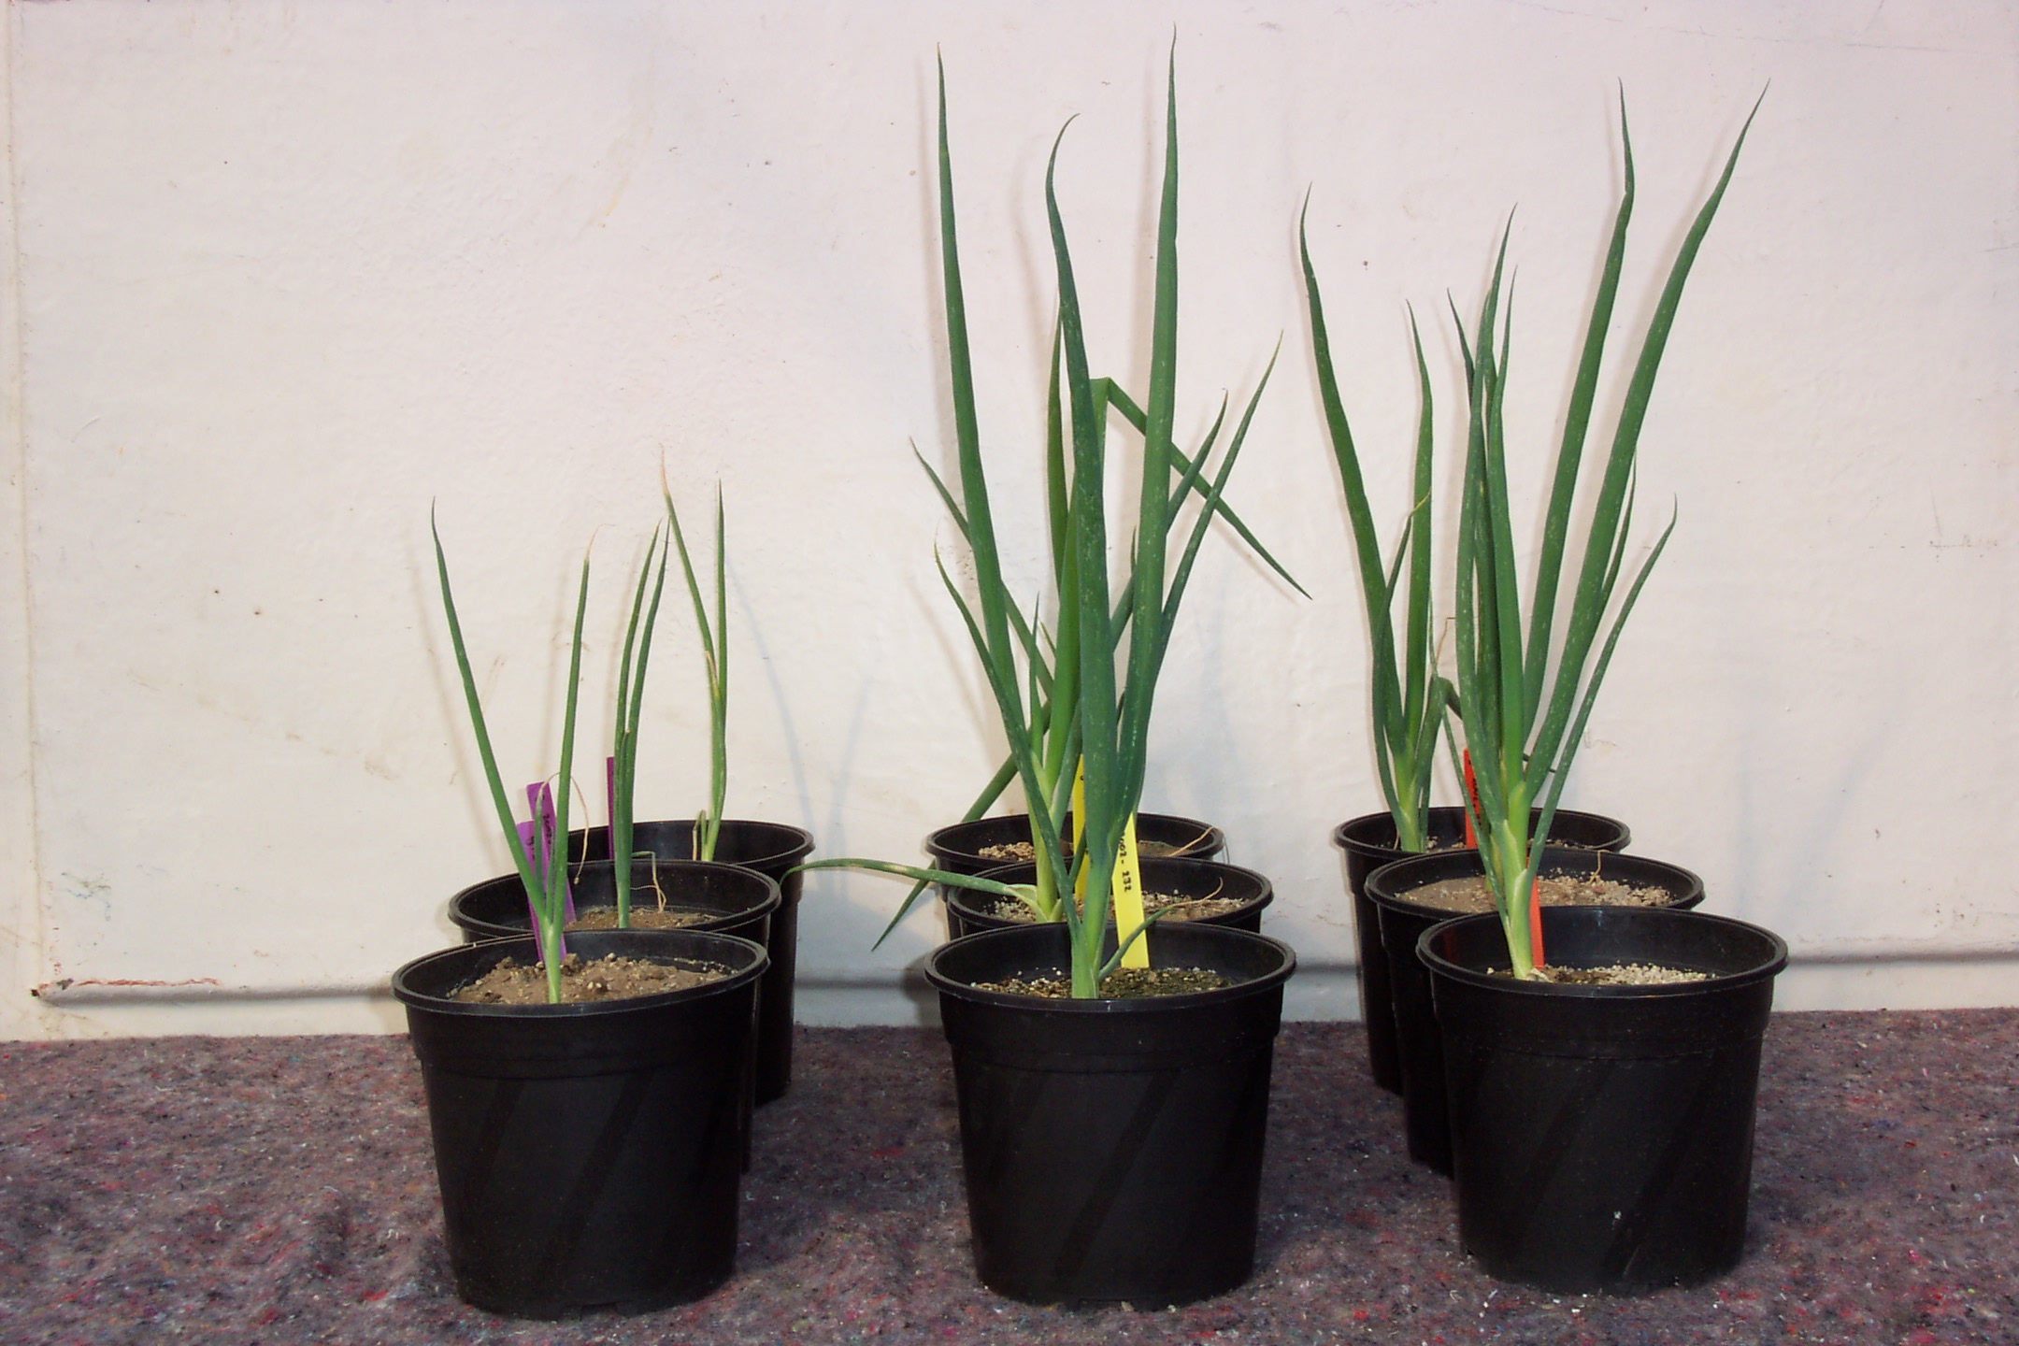
Figure 1. Effect of AMF added to Allium species growing in a pot experiment positively influenced plant height (left: without AMF, middle and right: with AMF).

Figure 2. Average plant height of four Allium species grown in pots in the greenhouse.

Figure 3. Relative increase in plant height of six onion cultivars grown in pots in the greenhouse after adding AMF in relation to control pots.

Field experiments
As expected, results from the field experiment where less pronounced than results from the greenhouse experiment. Large significant positive effects with respect to plant height, number of leaves and weight were found for A. fistulosum. This species is very interesting in breeding for organic farming. Apart from its high mycorrhizal responsiveness, A. fistulosum is known for its large root system. (De Melo, 2003). A larger root system results in a better uptake of minerals and makes plants less sensitive to drought. In addition, A. fistulosum is an interesting species to improve onion through breeding by using A. roylei as a bridge species to introgress important traits from A. fistulosum such as resistance to a number of fungal diseases into A. cepa (Khrustaleva and Kik, 2000).

Acknowledgements
This work is funded by the Dutch Ministry of Agriculture, Nature and Food quality as part of Programme 388-II Breeding for Organic Farming.

References

Brewster, J. (1994). In: "Crop production Science Horticulture", pp. 236, ed J. Atherton. (CAB International, Wallingford, United Kingdom).

Charron, G., Furlan, V., Bernier-Cardou, M., Doyon, G. (2001). Mycorrhiza 11 : 187-197.

De Melo, P. (2003). The root systems of onion and Allium fistulosum in the context of organic farming: a breeding approach. PhD Thesis. Wageningen Agricultural University.

Greenwood, D.J., Gerwitz, A., Stone, D.A. and Barnes A. (1982). Plant and Soil 68:75-96.
Portas, C.A.M. (1973). Plant and Soil 39: 507-518.

Khrustaleva, L. and Kik, C. (2000). Theoretical and Applied Genetics 100: 17-26.

Ryan, M.H. and Graham, J.H. (2002). Plant Soil 244: 263-271.

Stribley, D.P. (1990). In: "Onions and Allied Crops, Vol. II", pp 85-101, eds H.D. Rabinowitch and J.L. Brewster. (CRC Press, Boca Raton).

Wininger, S., Gadkar, V., Gamliel, A., Skutelsky, Y., Rabinowitch, E., Manor, H. and Kapulnik, Y. (2003). Symbiosis 35: 117-128.

Olga E. Scholten, Guillermo Galvan-Vivero and Karin Burger-Meijer are with Plant Research International (PRI), Wageningen University and Research Centre (WUR), Wageningen, The Netherlands. Jacqueline Baar is with the Applied Plant Research, WUR, Horst, The Netherlands. Chris Kik was with PRI and is now with the Centre for Genetic Resources, the Netherlands (CGN), WUR, Wageningen, The Netherlands.

