Title:
Case Ecopro biogas
Energy and nutrients towards the end of the food chain

Løes A.-K.¹, Thakur M.², Eilertsen A. ², Fløan T.³

OWNERSHIP AND EMPLOYEES: 51 municipalities in Nordland and Nord-Trøndelag counties decided in 2002 to cooperate on treatment of organic waste, and established a biogas plant in Verdal in 2008. 7 people are employed, and the plant is continuously managed (24/7/365).
SUBSTRATES: About 35 000 tons of source-separated household waste (about 50% of weight), sewage sludge (40%) and animal bi-products including fish (category II, 10%) sludge are treated in the biogas plant each year. The capacity is 50 000 tons. One kg organic waste gives about 1 kWh of energy.
PROCESS: Substrates are grinded and heated to 165 °C for 20 minutes at a pressure of 6 bar, thereafter the pressure is suddenly released. The resulting “steam explosion” (CAMBI) tears cells and fibers apart, and ensures pathogen sanitation, but also increases the energy output significantly.
ENERGY: Annually, about 30 GWh of energy is produced in the form of biogas, with about 65% methane. This is enough to supply 50% of the fuel demanded by the buses in Trondheim, which currently has more than 10 buses fueled by gas. Until now, the gas is incinerated to produce electricity, and 4-5 GWh per year is delivered to the el-grid. Larger economic surplus may be achieved by upgrading the biogas for fuel.
FERTILIZER: Digestate is split into a solid fraction (ca 22 % DM), and reject water (1-5%) DM. Some reject water is re-used in the plant. Residual reject water has been treated by the municipal sewage system, but caused problems of clogging (struvite). Ecopro aims for a complete utilization of the reject water in nearby agriculture, encouraging farmers to establish lagoons for storage. The fertilizer value is 25-25 NKK per ton, when the N-concentration is 0.5 % (4%DM). Solid digestate, rich in P and organic matter, is delivered to a nearby farmer for further stabilization, and can be utilized for soil production.

OPTIMISING STEPS: Biogas volume for upgrading may be increased by:
- Installing equipment to heat substrates by wood incineration
- Increasing the volume of treated substrates up to the plant’s limit, 50 000 tons per year
- Better management of the mixture of substrates

PART OF THE CYCLE: Treating organic co-streams by anaerobic digestion gives valuable bioenergy, and concurrently facilitates recycling of nutrients and organic matter from farmers’ fields, via processing, distribution and consumption, back to farmer’s fields again. Hence, biogas plants are an integrated part of the value chains for chicken, vegetables, potatoes, and gradually also for fish, as fish production becomes stronger integrated in land-based production (terrestrial feed, recycling of fish sludge to soil).

¹ Norwegian Centre for Organic Agriculture (NORSØK), ² SINTEF Fisheries and Aquaculture, ³ Ecopro biogas plant, Verdal, N. Trøndelag, Norway

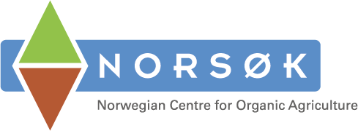

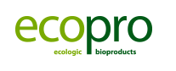
Poster presented at the Copenhagen Conference on Research and Innovation Pathways towards a Circular Bio-economy,
DGI-byen, 25-26 October 2016

