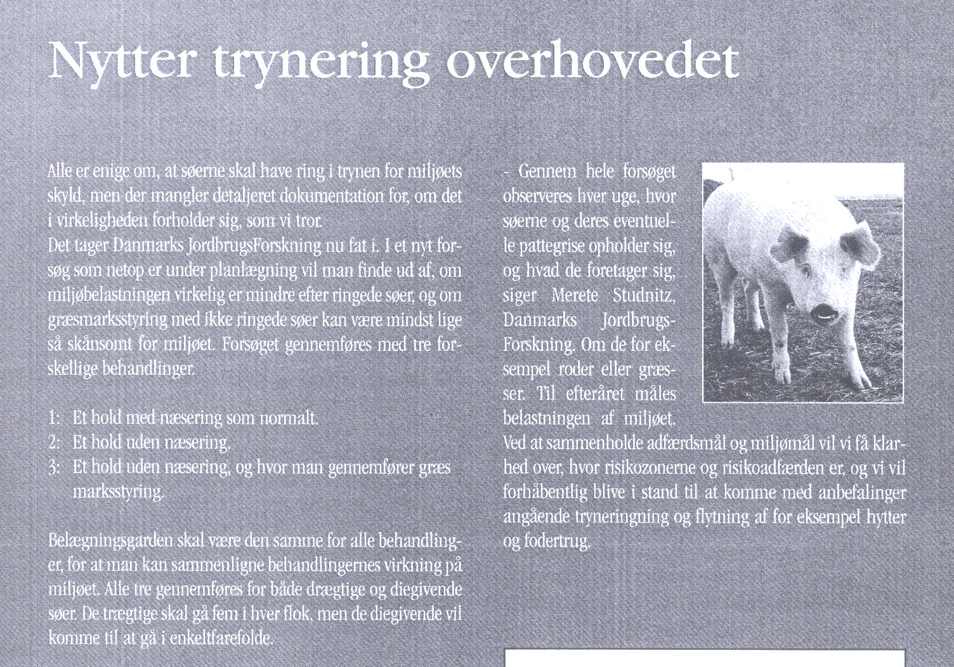
Archived at http://orgprints.org/00001879

